Cover Page

Table of contents

Introduction

SOPS

# ADMINISTRATOR

## Systems installation

1. **Required Materials**
   1. Laptop or Desktop
   2. Windows 10 and above operating system
   3. 500 + GB storage
   4. 8 GB RAM
   5. Core -i5 processor 1.3 GHz +
   6. 25-inch monitor for desktops – better view
   7. Local Area Network connections or Wifi (for use with tables and phone)
2. **Server and Database**
   1. Apache Server 2.4 and above
   2. Mysql-8.0.3-winx64 and above
3. Download Apache servers and MySQL from official websites or folder in the link and extract using unzip software. Download link: <https://drive.google.com/drive/folders/1L1a0NDPmEMZE7GNLnji4pAZPvSTxgoP-?usp=drive_link>
4. Install the server as an administrator by following the installation wizard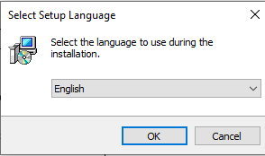
5. Click Next for installation to complete. Once it is installed. Close the application

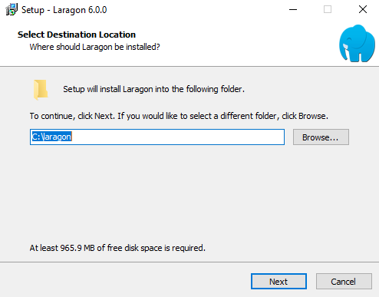

1. Confirm if Laragon or whichever server (XAMPP or WAMP) is successfully installed by checking in the taskbar or search panel.

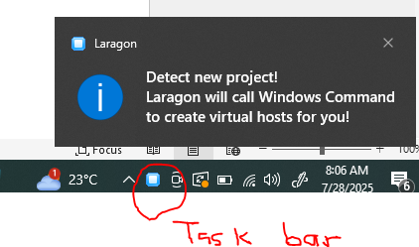

1. This level will require internet connection to download the phpMyAdmin and install along

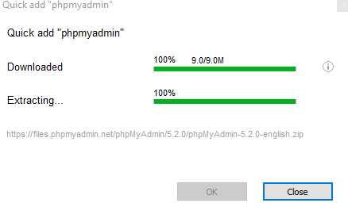

1. This will open this page: Username: **root**

Password: leave blank

Click Login

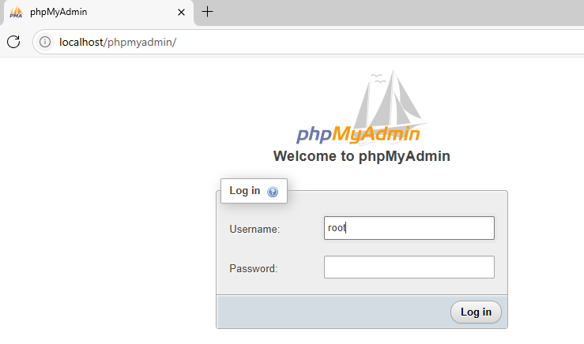

1. Download the project folders from <https://drive.google.com/file/d/1V8ywMDUk6NCiKcup9CaSP76vElru-WjK/view?usp=drive_link> and unzip to the laragon folder www or htdocs for XAMPP and give it your desired name example: **Methadone**



This PC > Local Disk (C:) > laragon > www > IORPMS

This PC > Local Disk (C:) > XAMPP > htdocs > IORPMS

1. This will open the following screen. Click on Databases and enter: **methadone** and choose **utf8mb4_general_ci** collation

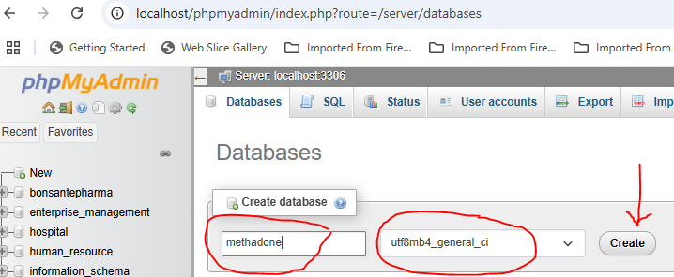

1. Import database from the folder C:/laragon/www/IORPMS/backup/database/iorpms.sql

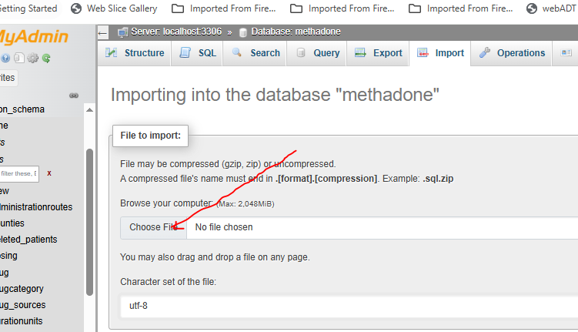

Type the following in url and press enter key <http://localhost/iorpms/>

1. This will open the following screen

Username: admin

Password: 123456 and login

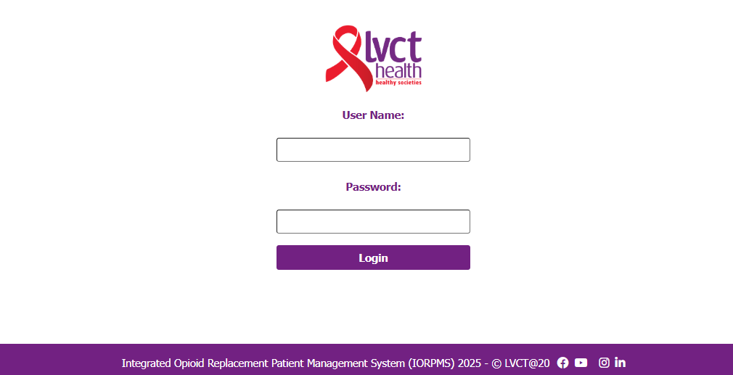

1. This will open the following landing page which is home page:

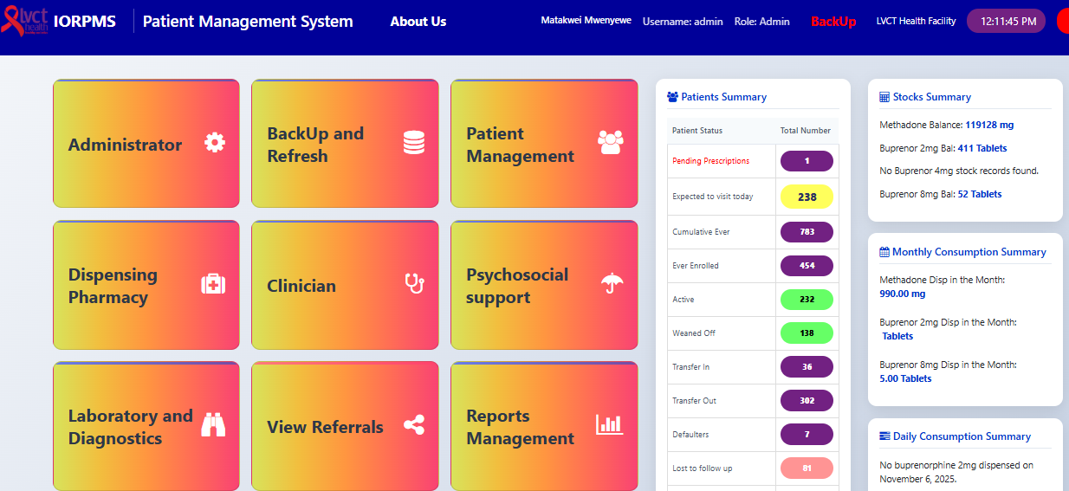

Disclaimer: You can now navigate to the module of interest. Not all users will see all modules

## Facility initial setup

1. Open Administrator module by clicking on it as shown is Systems installation procedure 13.
2. Go to facility setup

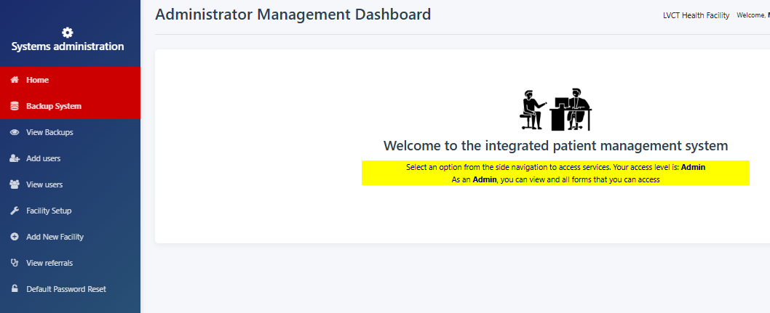

1. Select the facility and other settings will auto-populate and then fill in the facility in charge, phone and email and save and submit

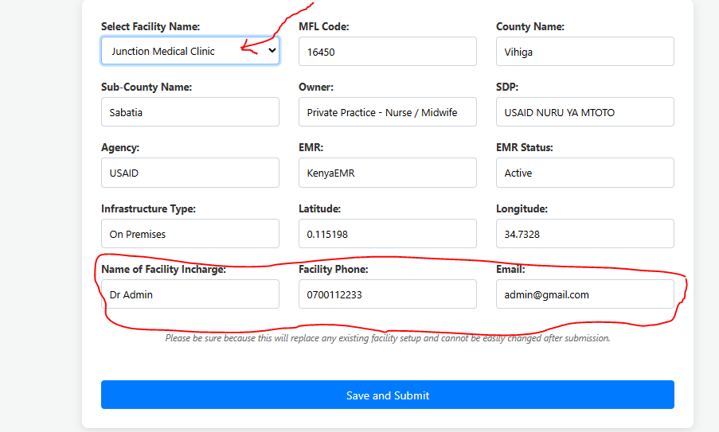

1. Click home to navigate back to home page and you should see the facility name displayed:

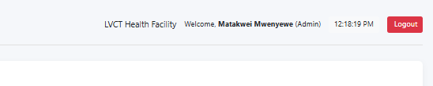

## Backups

1. Open Administrator module by clicking on it as shown is Systems installation procedure 13.

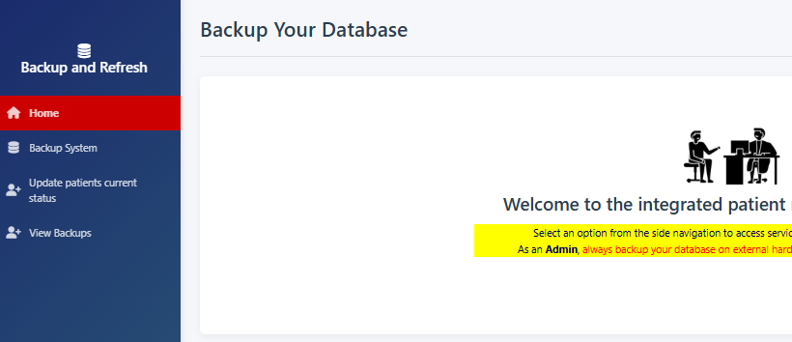

1. Click on backup system and you should see success message
2. Click view backups to see if the backup for the date is available

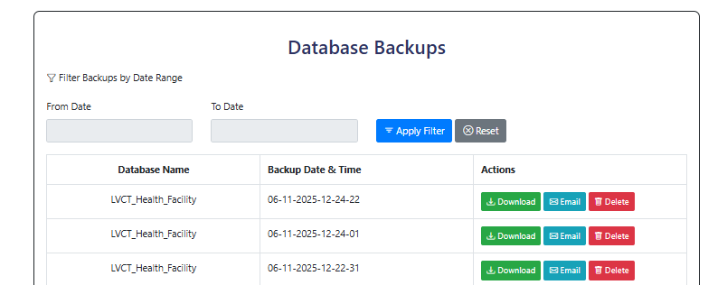

1. Click on download button to download the backup into the downloads folder
2. Click email to email the backup to the default email setup – still under development

## Add users

1. Click view users and search the name of the user you want to add

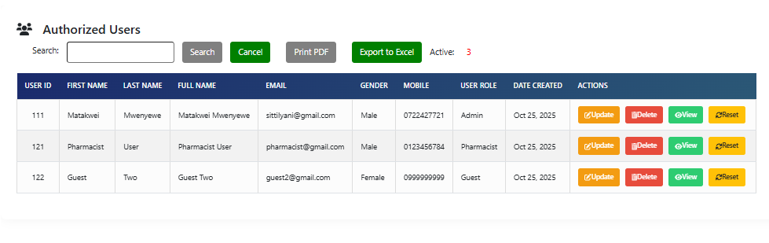

1. If the user doesn’t exist then, then click Add Users tab

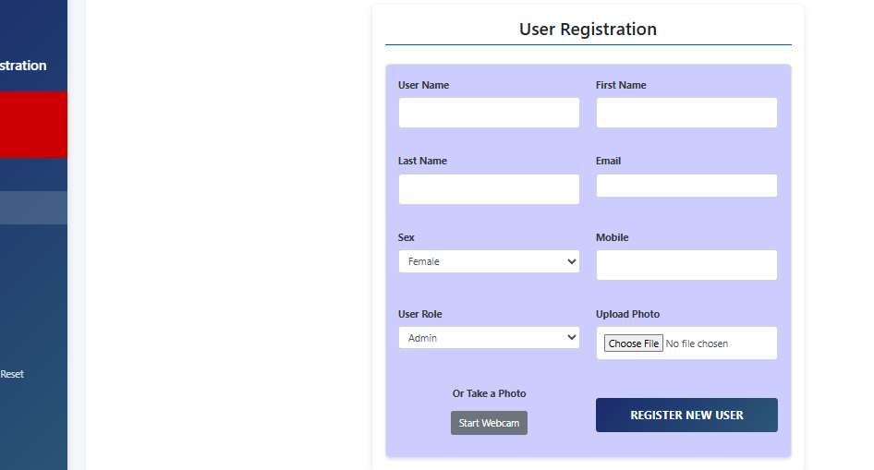

1. Input all required fields and submit by clicking ‘REGISTER NEW USER’ button
2. The system will automatically logout and you need to log in again

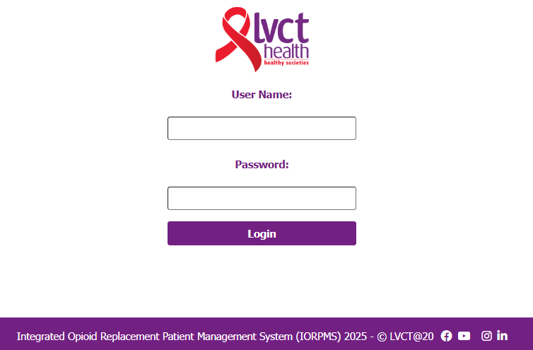

1. Enter your created username and default password “123456” to login again

## Change password

1. Login the system and select profile module
2. Click change password tab. Input 123456 as old password and input your preferred password and confirm by entering the same as new password and click update password

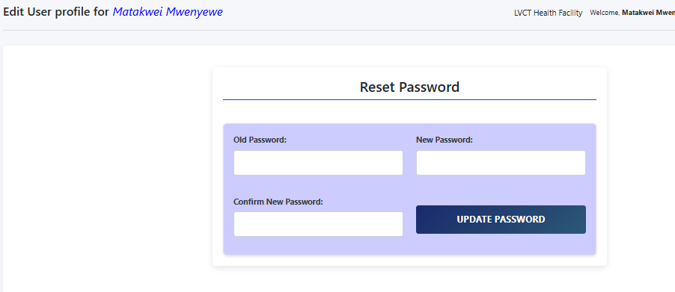

## Referrals

1. Click on view referrals to see all referrals submitted to different departments

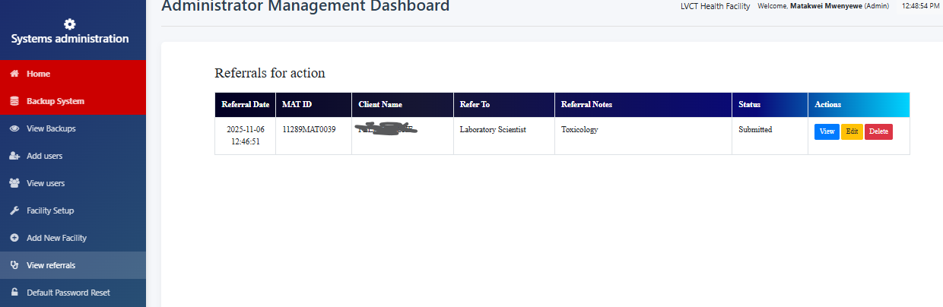

1. Click view to see the prescription details. The submitted date prompts for action.

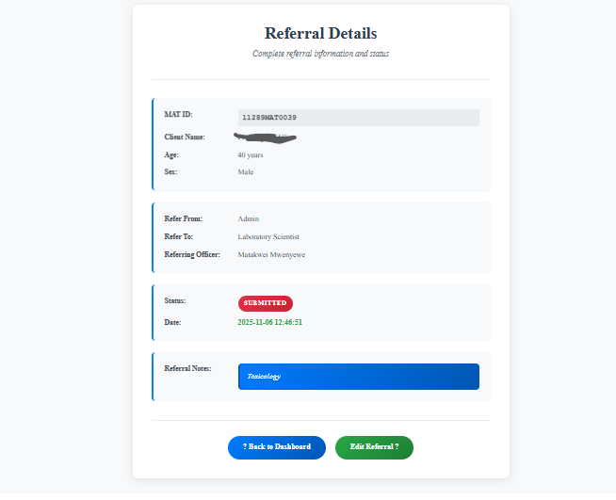

1. Delete button deletes the referral
2. View button displays the referral foe review or complete status

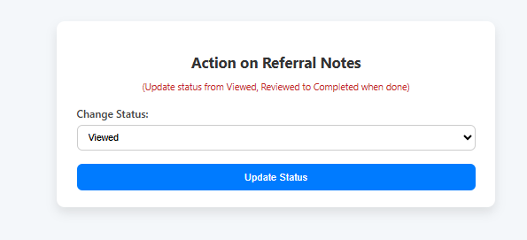

## Password resets

1. Click on the Default Password Reset tab to open the following:

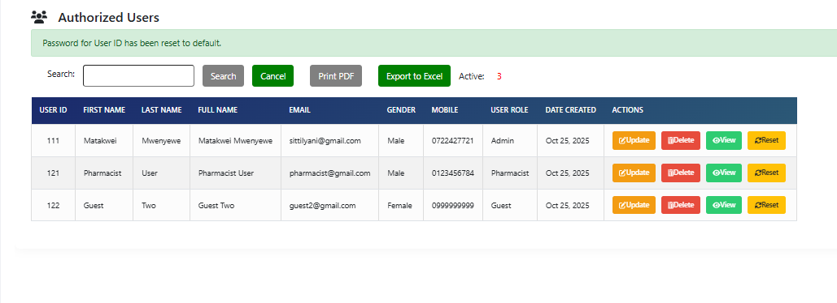

1. Update button updates the user details except the username

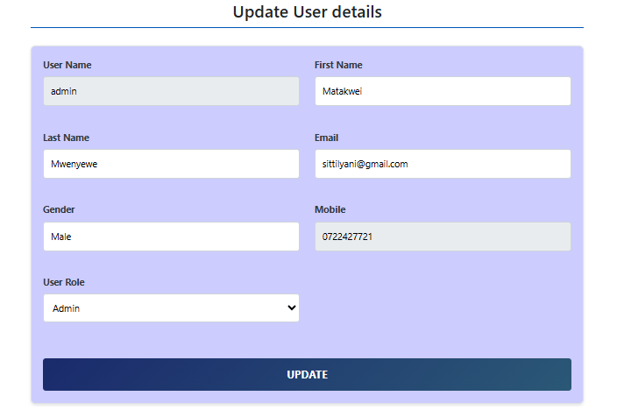

1. View button views the user details and you can navigate back to users’ list
2. Reset button resets the user password to **“123456”**

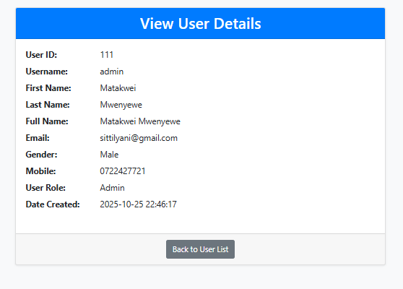

# BACKUP AND REFRESH

## Backup System

1. Open Administrator module by clicking on it as shown is Systems installation procedure 13.



1. Click on backup system and you should see success message
2. Click view backups to see if the backup for the date is available



1. Click on download button to download the backup into the downloads folder
2. Click email to email the backup to the default email setup – still under development

## Update patients’ current status

1. Click on update patients’ current status if the system was not on and you will see output like this below

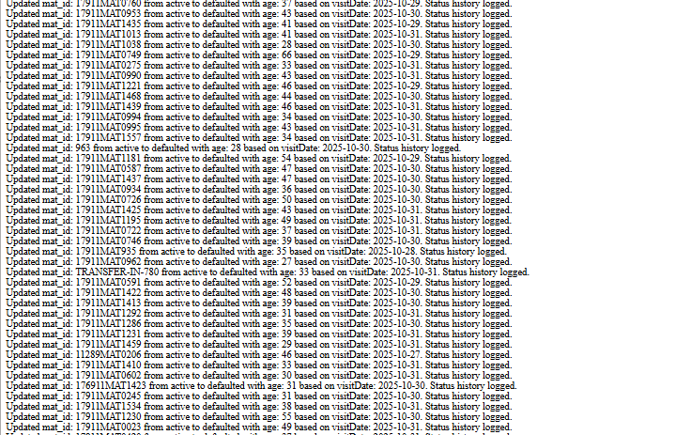

Active Patients who had missed more than 5 doses will change to defaulters

Defaulters who have missed more than 25 days from the day of default will change to LTFU (lost-to-follow-up)

## View backups

1. Click view backups to see if the backup for the date is available



1. Click on download button to download the backup into the downloads folder
2. Click email to email the backup to the default email setup – still under development

# PATIENT MANAGEMENT

1. Select the patient management module from the landing page

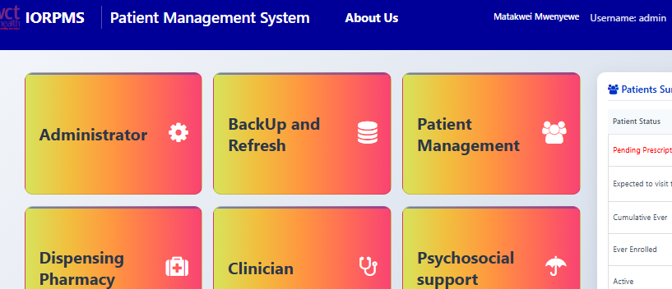

## Register New Client

1. Click on the Register New Client tab to open the following

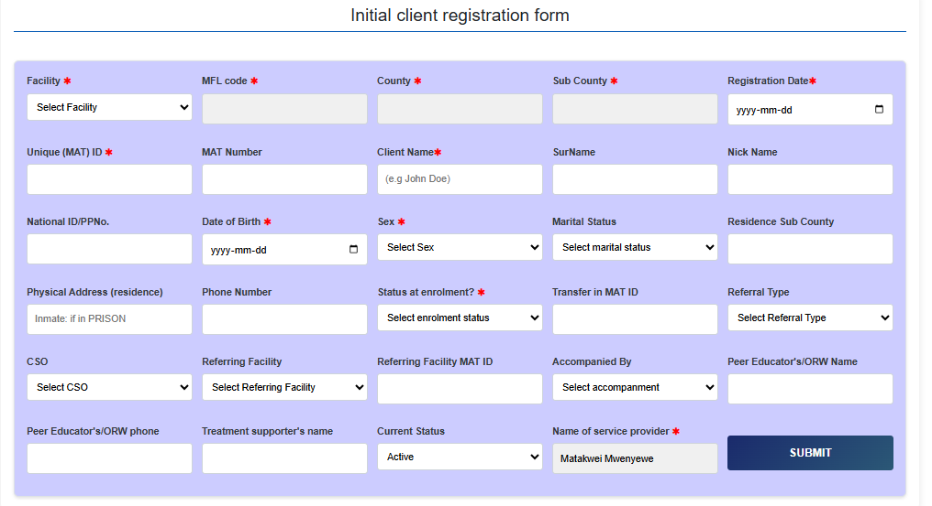

1. Select facility name from drop down
2. The MFLCode, County, Sub will auto populate from the database
3. Select registration date which can’t be in future
4. Unique MAT id uses MFLCode – MAT- 00001 or as per the clinic Standard operating Procedure example for LVCT Health clinic 99999MAT00001 where 99999 is MFLCode for Client number 00001
5. For Transfer In clients use their existing MAT ID Number
6. Client Name is example ‘John Doe’
7. Select Date of Birth which should be at least 15 years
8. Select sex
9. Fill the Physical address – if the clients is in prison - **INMATE**
10. Select enrolment status
    1. **New** is Induction
    2. **Transfer In** for clients from other facilities already on Methadone or Buprenorphine
    3. **Transit** is for those clients who will be taking methadone or buprenorphine for not more than 30 days and go back to their MAT facilities
11. Fields marked with asterisks are mandatory but if the registering officer has time, please update all fields
12. The unfilled fields can be updated later

## View Clients categories

1. Click on each category to view the number and details of patients in each category. Example below for ever-enrolled clients

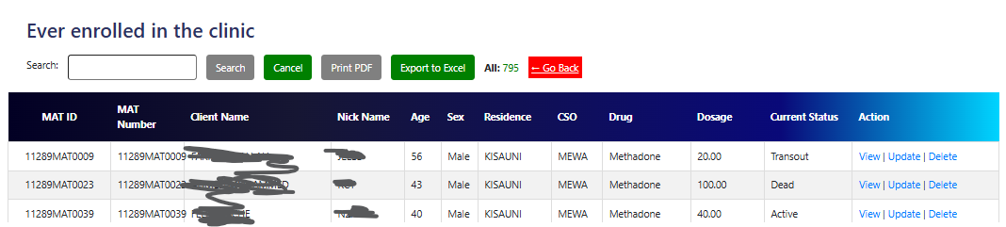

1. Current status shows the status of the client at that time e.g. dead, transfer out, weaned etc
2. View displays client details with photo if taken

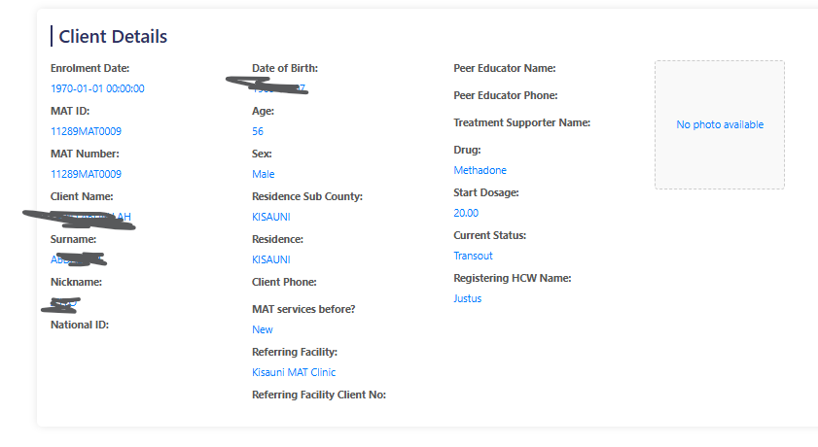

1. The update button opens the patient profile to edit

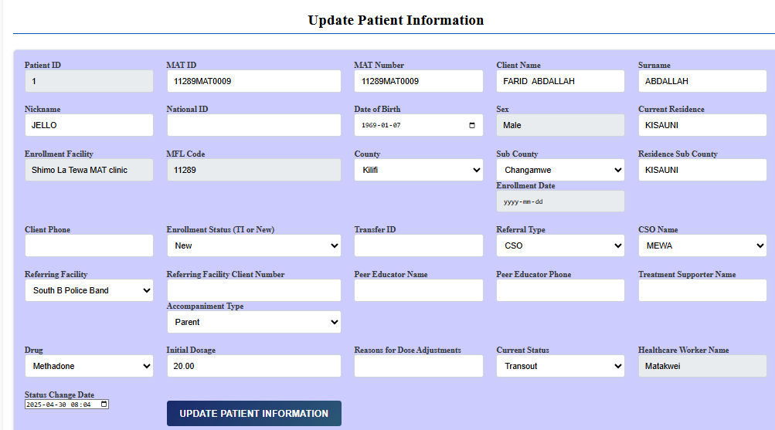

1. Delete button deletes the patient from database records.

# DISPENSING PHARMACY

1. Access the pharmacy module by clicking on ‘Dispensing Pharmacy’ on the dashboard

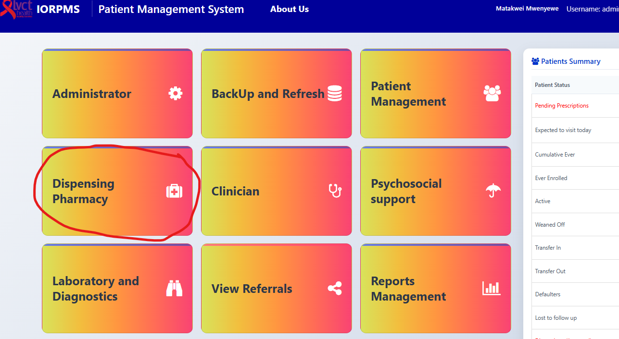

1. Navigate to specific sections as below:

## Dispense without pump – Buprenorphine

1. Click the ‘Dispensing without pump’ to open the search window

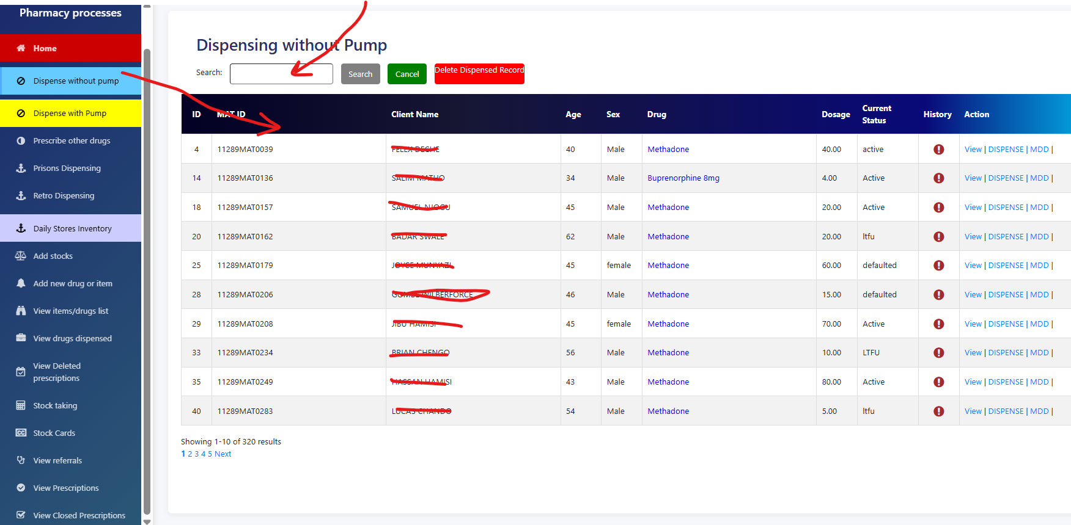

1. Type the client’s name, or MAT ID to find the patient. Clients identify themselves by their MAT IDs or Full Name
2. Click on History icon to view the patient dispensing history

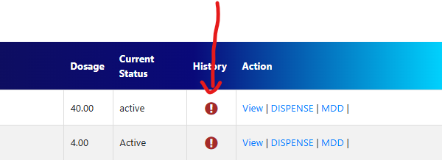

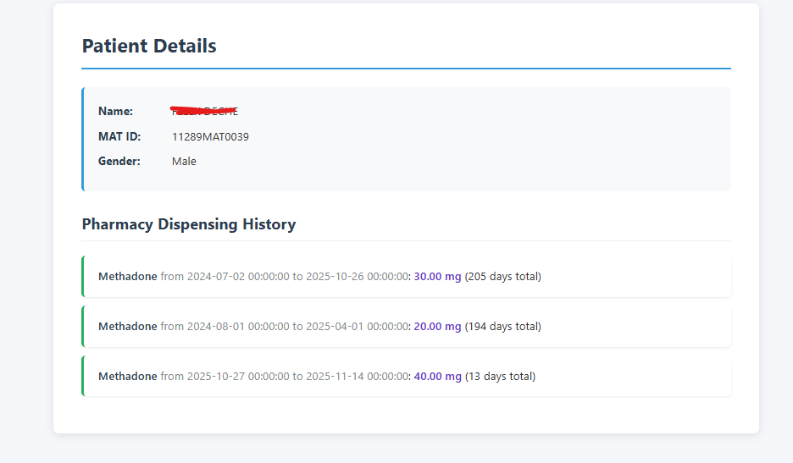

1. Click on the ‘Dispensing’ to open the dispensing window for a particular client

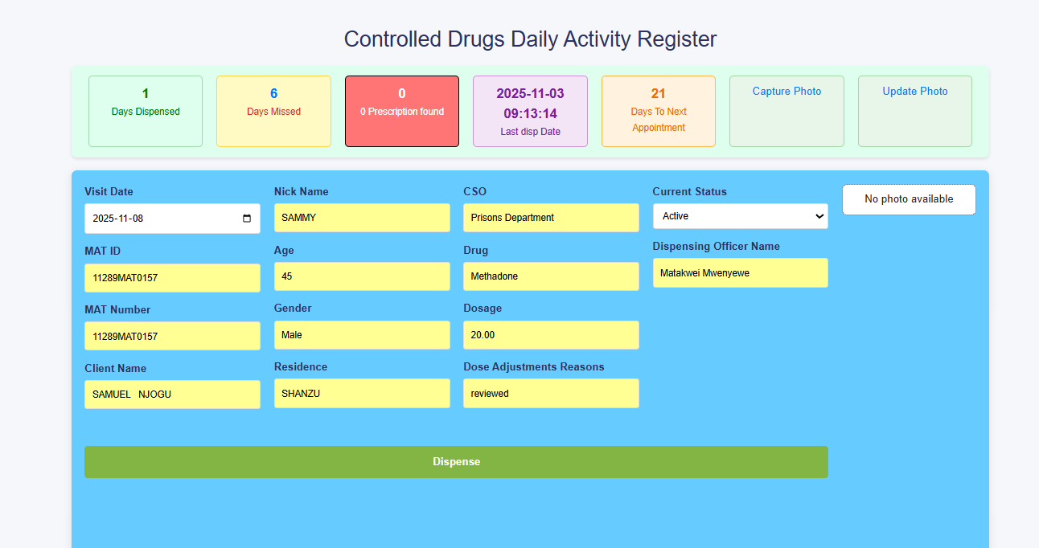

1. Confirm the dose, photo and once the right patient is present, click the green button ‘Dispense”
2. Wait for the success message. If successful will return to search window after 2 seconds for the next patient
3. The system will give error for the following:
   1. When the clients’ current status is NOT ‘Active’
   2. When the is no ENOUGH stocks in the dispensing system
   3. When the client dosage in ZERO
   4. If ‘Days to Next Appointment’ is ZERO
4. If there are other prescriptions alongside Methadone or Buprenorphine, they will display in the red display-card and at the bottom of the CD prescription

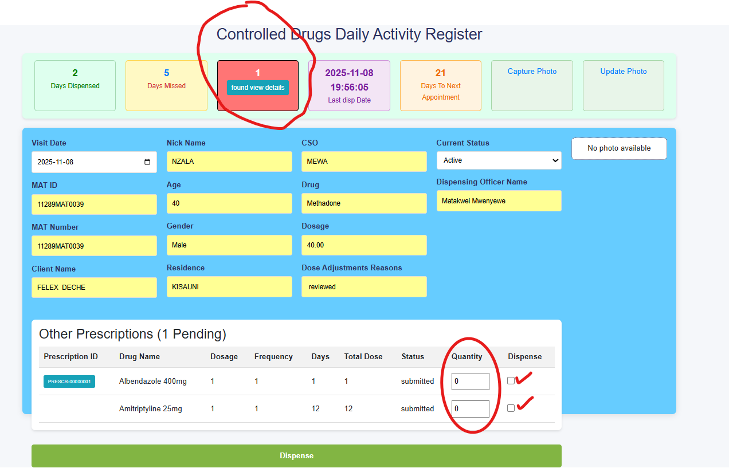

1. When the ‘Days to Next Appointment’ is ZERO, click on “Refer”

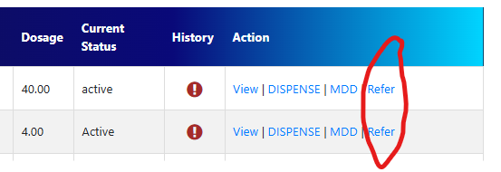

1. Select Clinician from the ‘Refer’ to adjust the dose or give the next appointment
2. In put the referral notes and send the client to clinician for review

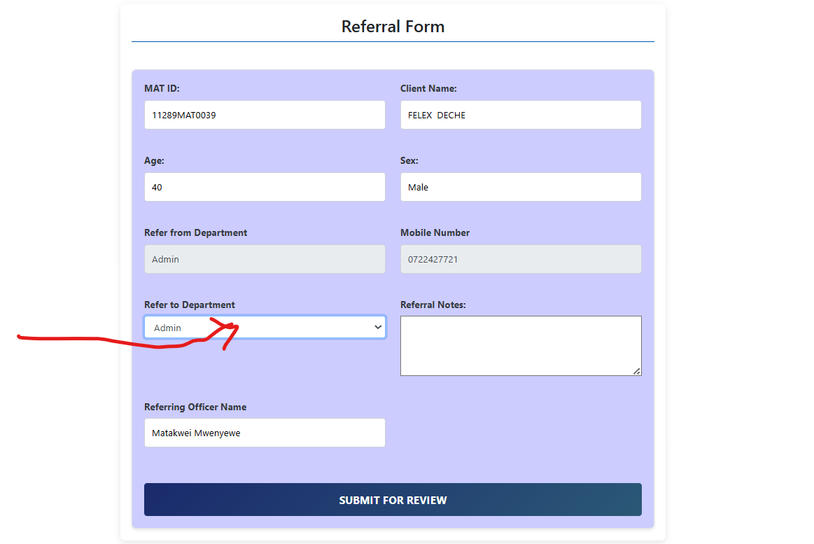

1. Also refer if missed appointment is More than 3 Days even if the client has a ‘Next Appointment’

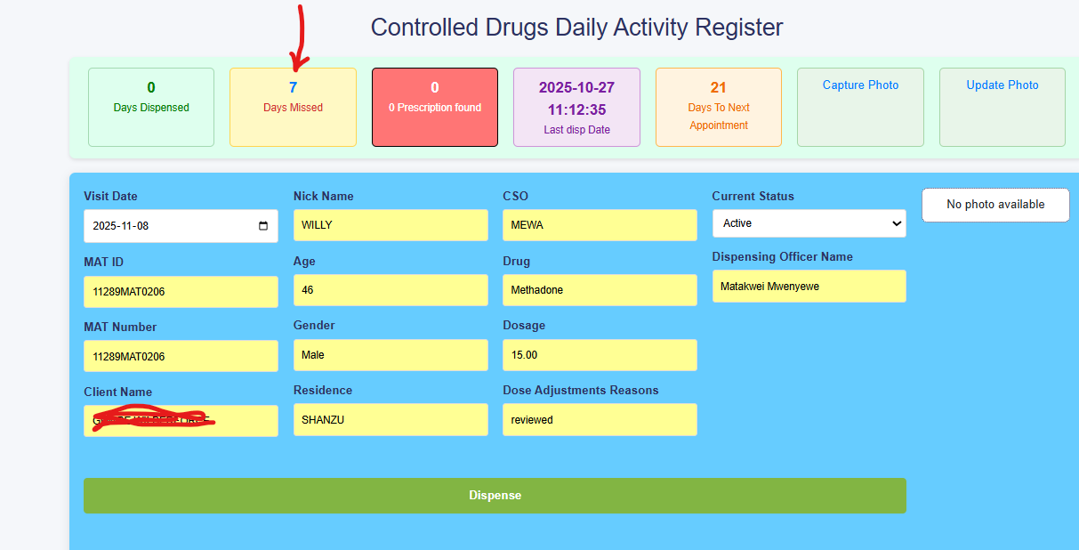

1. Click on the days missed to display the exact days missed

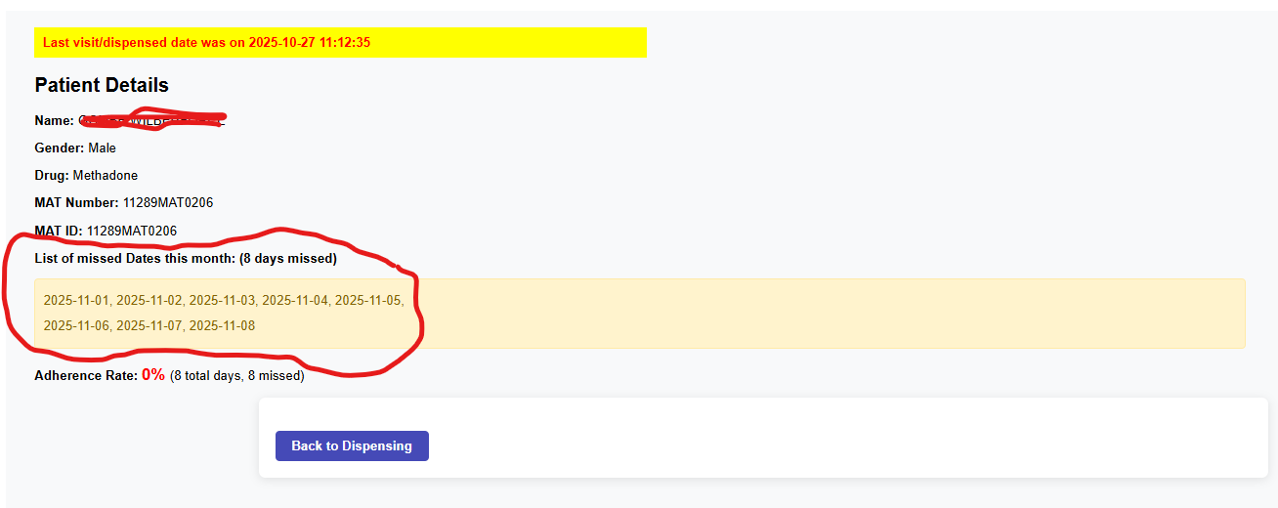

## Multi-Day Dispensing

1. Click on the MMD to display select the name of the client(s)

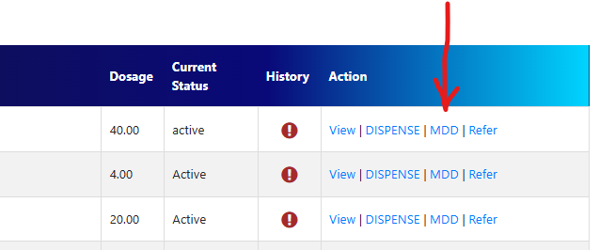

1. This will open the window below

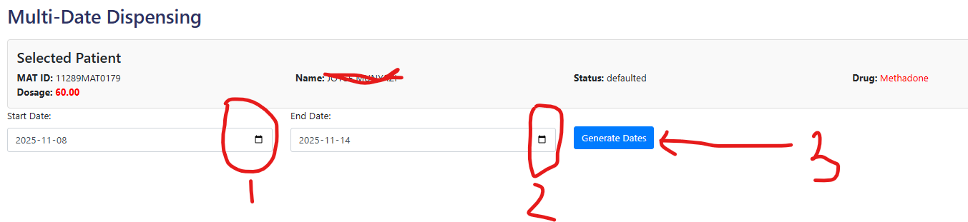

1. Select the start date, end date and click ‘Generate Date’ as shown below

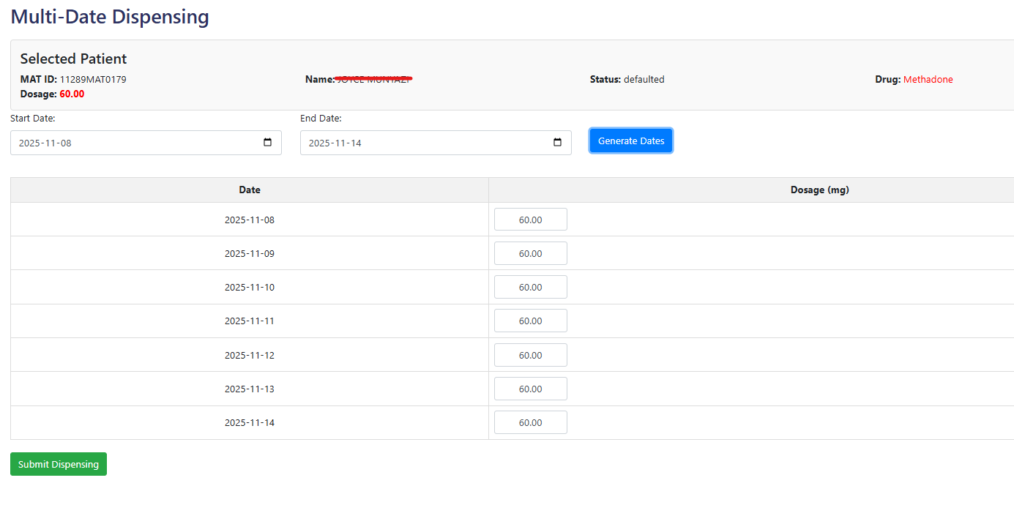

1. For the patients taking alternate doses, delete the days that should not be dispensed and click **‘Submit dispensing’**
2. Wait for the success message.
3. This is used to dispense for multiple days if the patient missed entries into the system due to system downtime or power failure.

## Dispense with pump – Methadone

1. Repeat the procedure as for Dispense without pump

## Prescribe other drugs

1. Click the prescribe other drugs and search for the client’s name. Once the client appears click prescribe

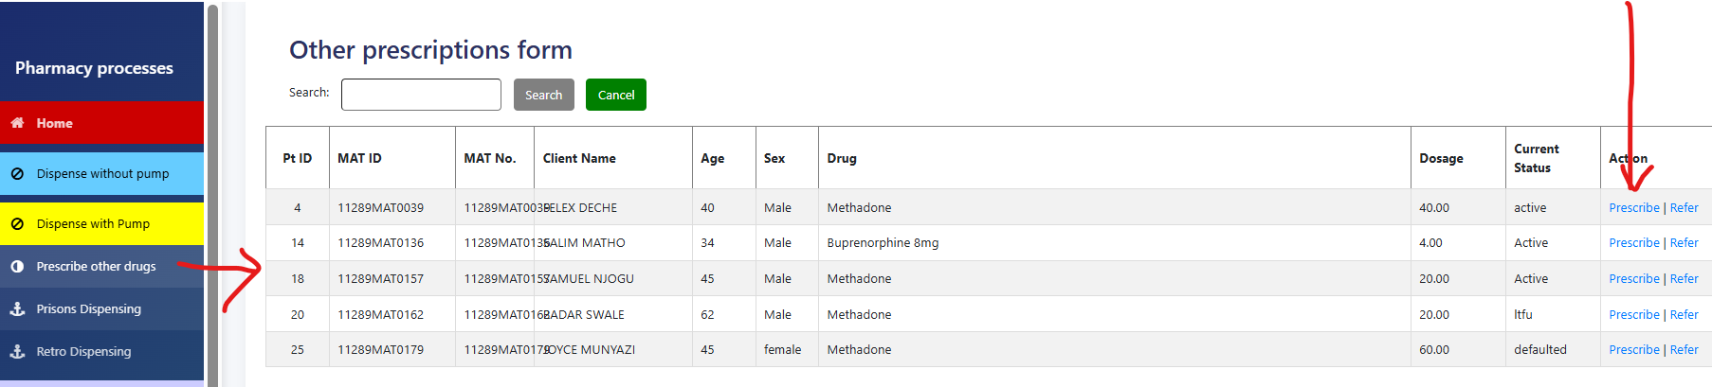

1. Select the drugs from the drug name drop down
2. Insert dosing, frequency and total days
3. The total dosage will auto-update
4. Click ‘Add drug’ to add the prescription to the cart
5. Repeat procedure 3 -5 if more drugs are prescribed
6. Press “save prescription’ once all drugs are added

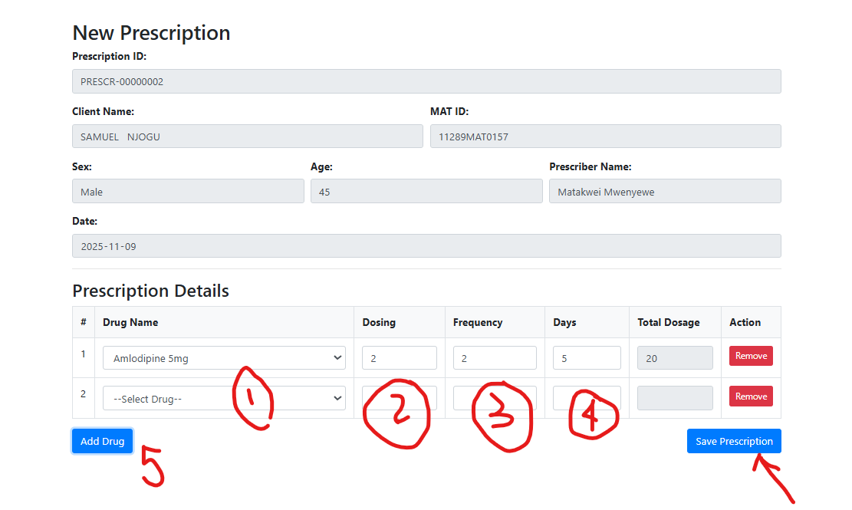

## Prisons dispensing

1. Click on ‘Prisons dispensing’ to open the window below

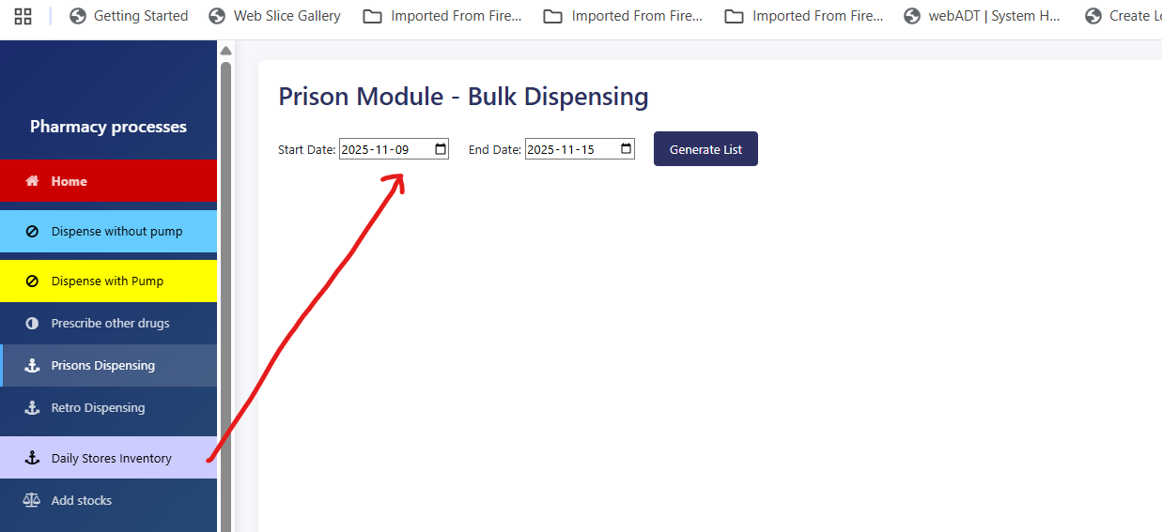

1. Select the date range and click generate List to generate a list of all clients in the prisons department who require Prisons delivery

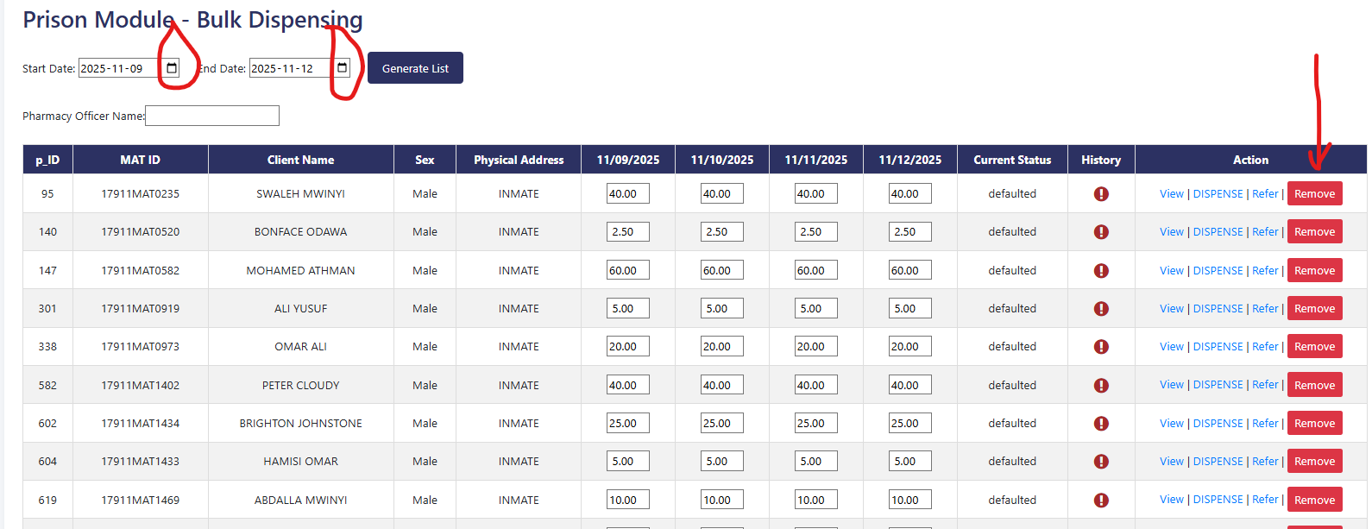

1. Click remove buttons to remove those clients not required
2. Input the ‘Pharmacy Officer Name’ delivering the doses to prison and press “Bulk dispensing”

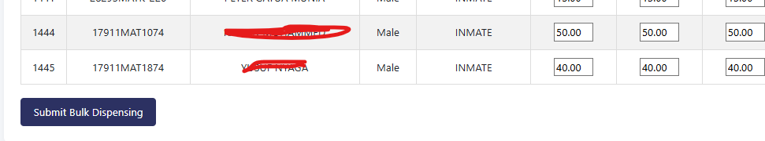

1. Wait for the success message by scrolling the page to the top, wait for at least 30 seconds
2. A summary of all dispensed doses will be displayed

## Retro-dispensing

1. Performance the procedure like in the prisons dispensing

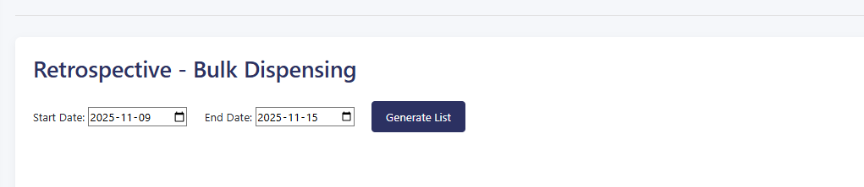

1. This procedure is done for already dispensed doses that were not documented in the system due to hardware or power failure

## Delete dispensed doses

1. Click on “Delete dispensed doses” to open the window below

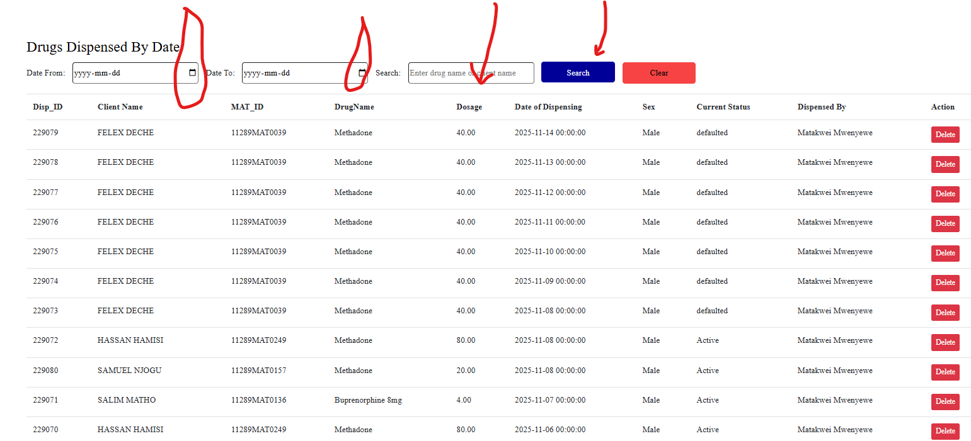

1. Select the date range to search for the prescription or the client name and press “Search”
2. Once the client Name is found, click on Delete

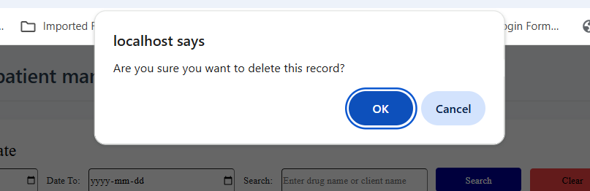

1. Press ‘OK’ once you are certain to proceed
2. Insert the reason for deleting the prescription at the bottom of the page and click “Confirm deletion”

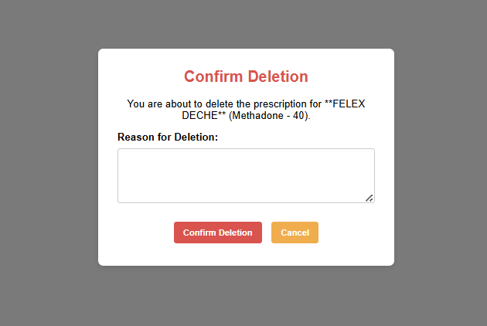

Wait for success message below

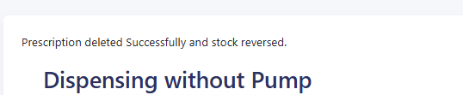

The page will redirect to dispensing

Press “Home” to go to dashboard

## Daily stores inventory

## Add stocks

## Add new drug or item

## View items/drugs

## View drugs dispensed

## View deleted prescriptions

## Stock taking

## Stock cards

## View referrals

## View prescriptions

## View closed prescriptions

# CLINICIAN

# PSYCHOSOCIAL SUPPORT

# LABORATORY AND DIAGNOSIS

## Routine test

1. Click on perform a test and enter the MAT id or name to search

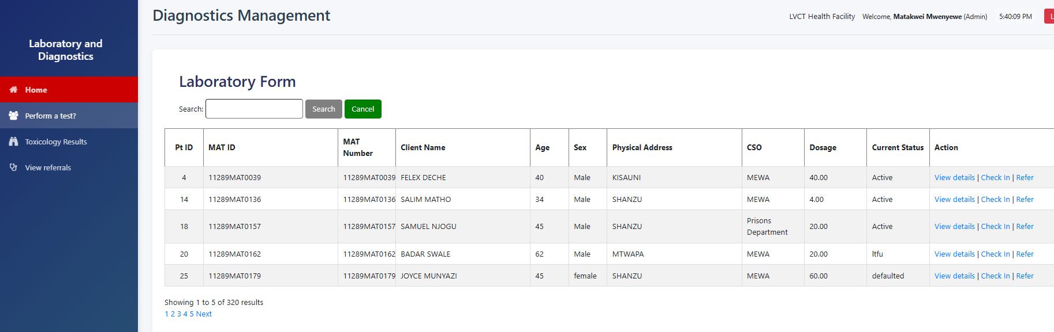

1. Click the ‘Check in’ tab to open the daily activity register

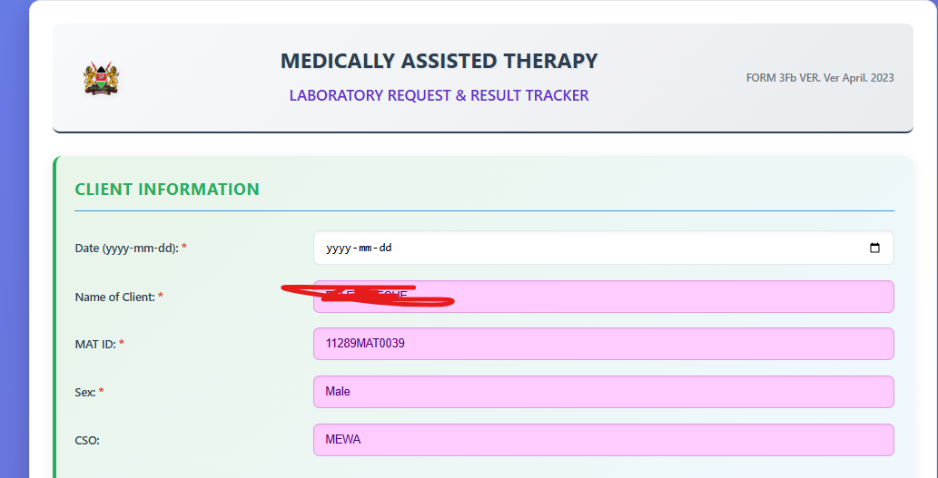

1. Select the date, visit type: New, or Routine or Re-induction of follow-up visit
2. Select the routine test results, either positive or negative or if not done – select “Not Done”

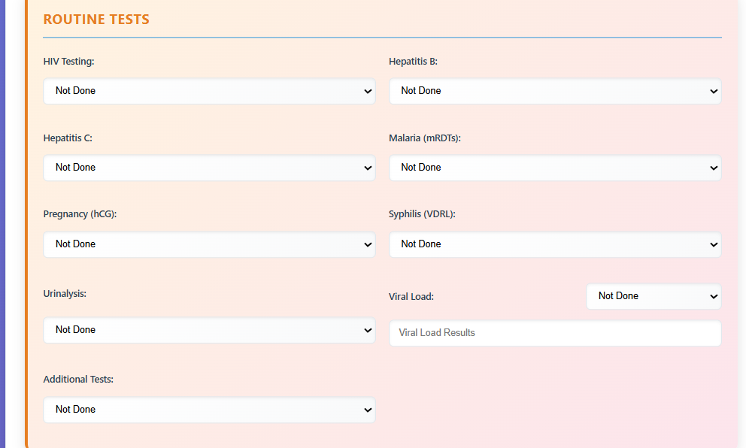

1. Select the toxicology results if done

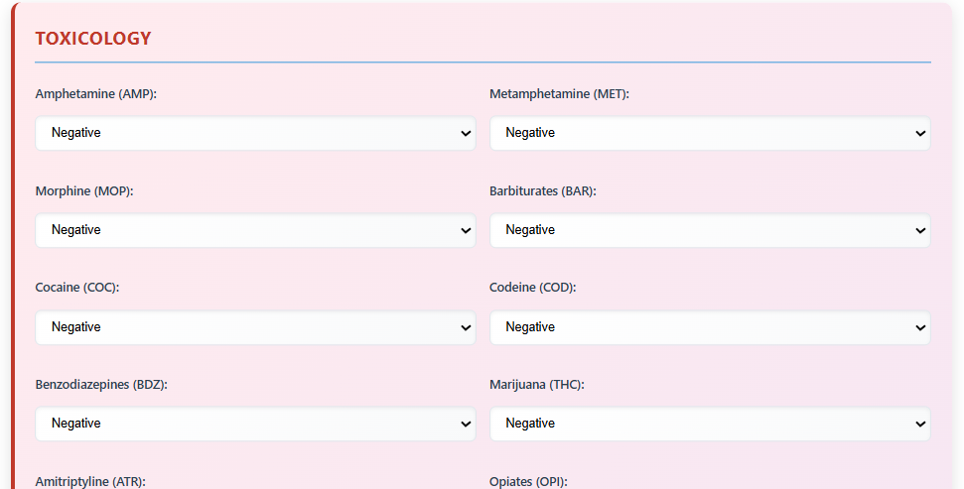

1. Make laboratory notes, input the date of test and next appointment and submit the results

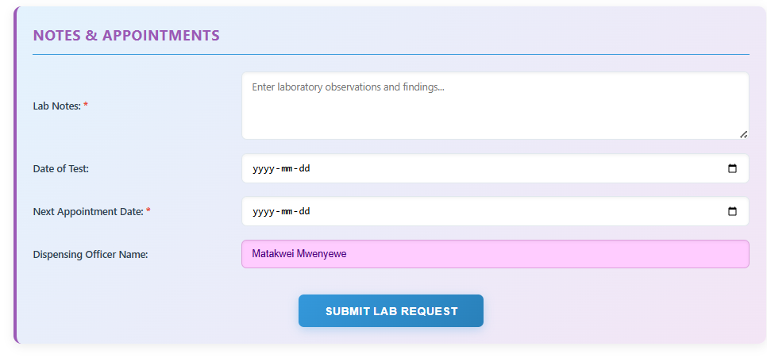

## Referrals

1. Click on Perform a test tab and select “refer” tab

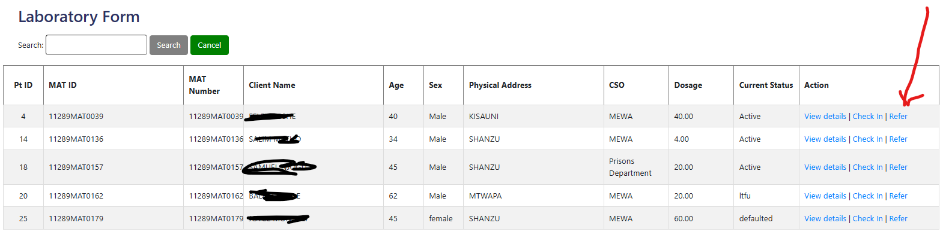

1. Select from the department where you want to make referral to and make some notes for the healthcare worker to review

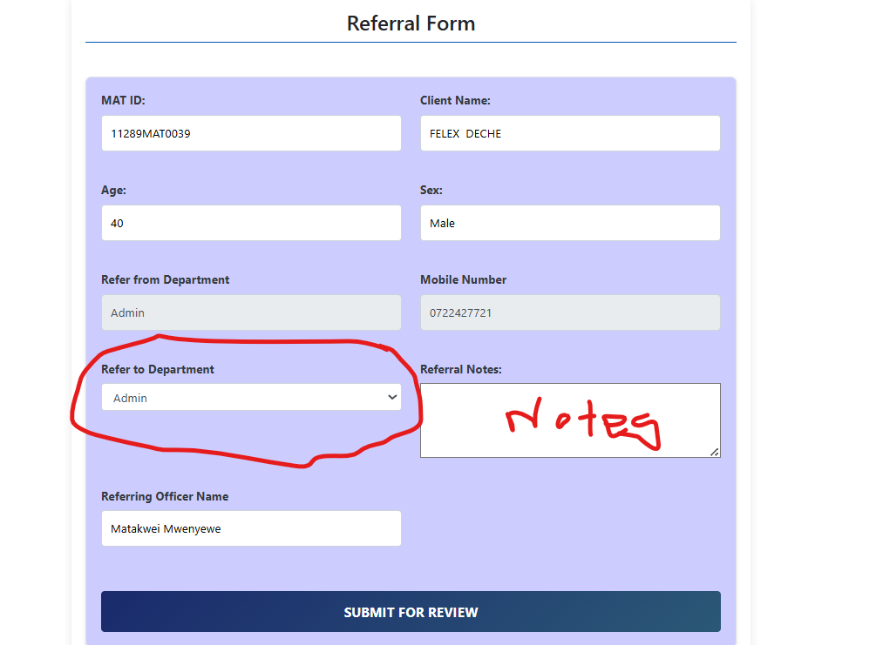

1. Click submit for the referral to go to the department



# VIEW REFERRALS

# REPORTS MANAGEMENT

## Daily clinic summary

1. Select the Reports Management module from the home landing page

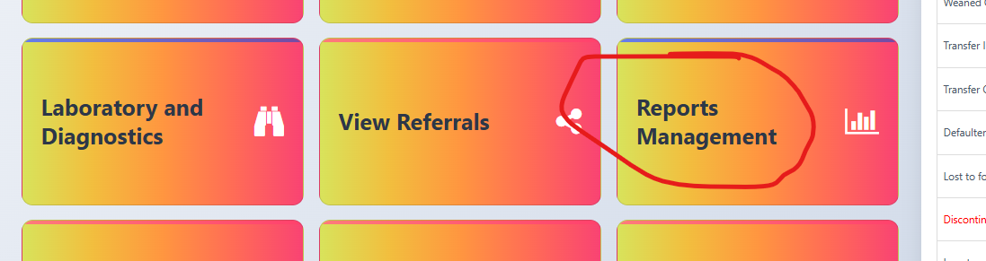

1. Navigate to each tab to view the details

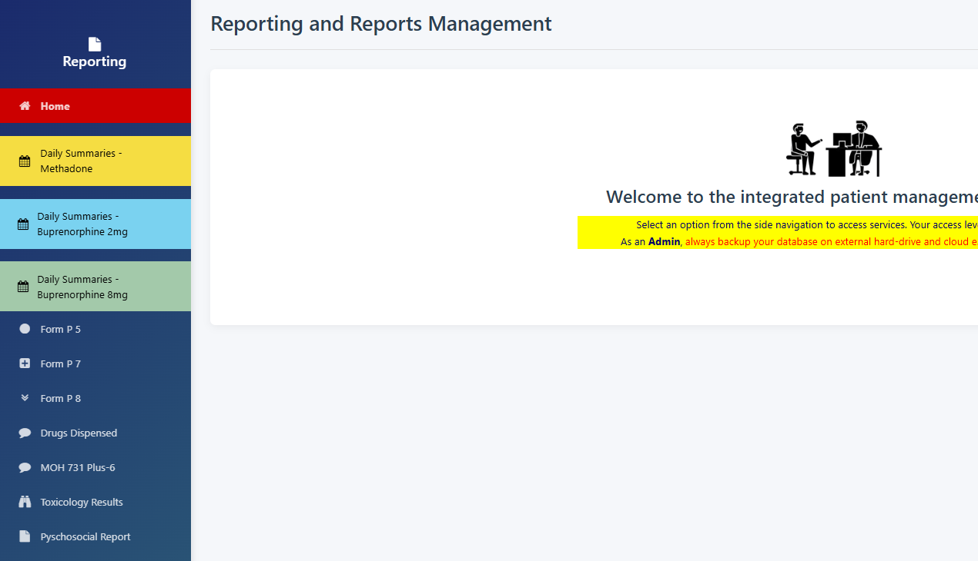

1. Select the Month though by default is the current month and click Update Report button to view summary for the month.
2. This display daily stocks movements from the controlled stores (STRONGROOM) to the dispensing area
3. The daily summaries are for: Buprenorphine 2mg, Buprenorphine 8mg and Methadone

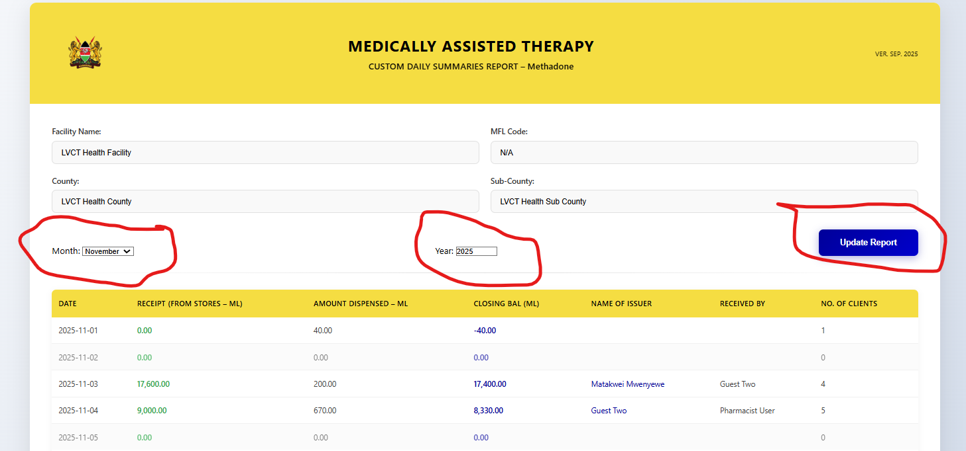

## P5 Form generation

1. For form P5 daily dispensing summary per patient:
2. Select Year from dropdown and Month from the Month dropdown and click submit button and wait for the report to run.

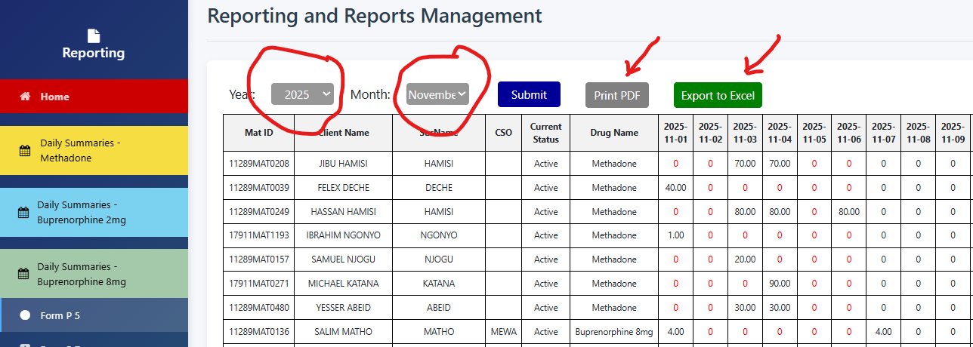

1. The output will take from 1 minute to 10minutes depending on the if it is run for the first time or subsequent refresh and also the number of clients.

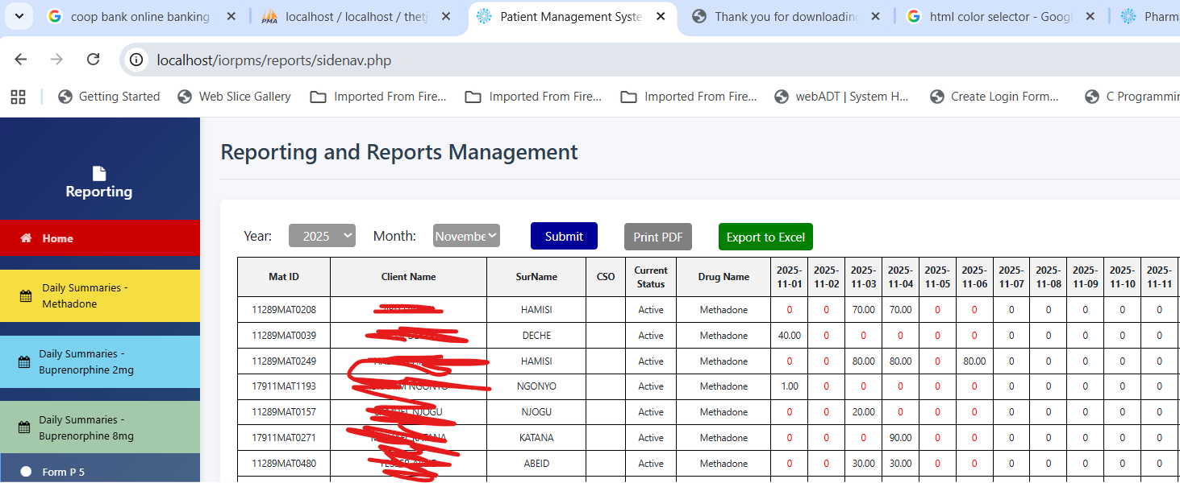

1. Check the url when the report is running until it stops

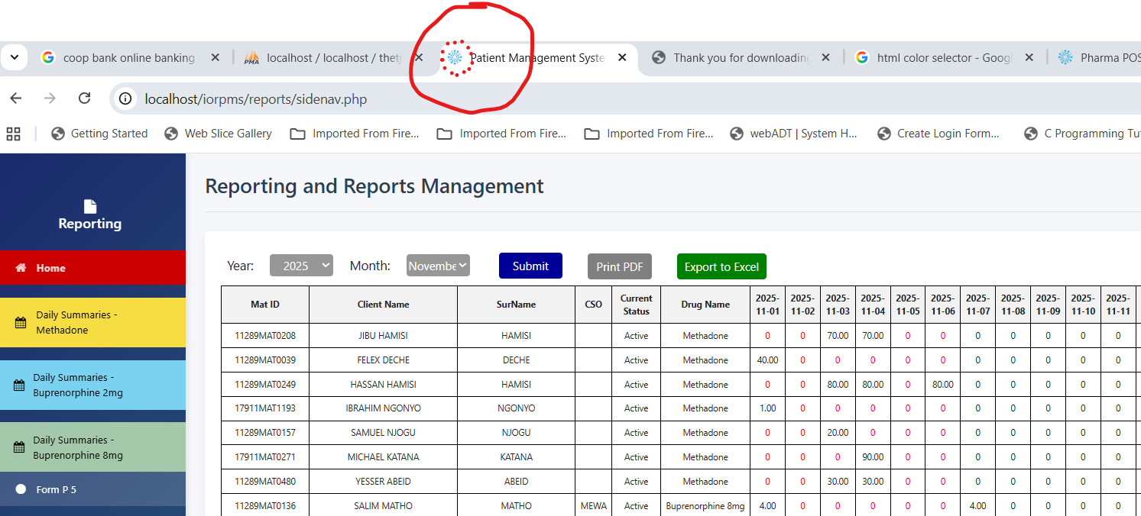

## P7 form generation

1. For from P7 when you select the Form P7 form it displays by default the report of the previous month. Example when the current month is November, the form will display report for October

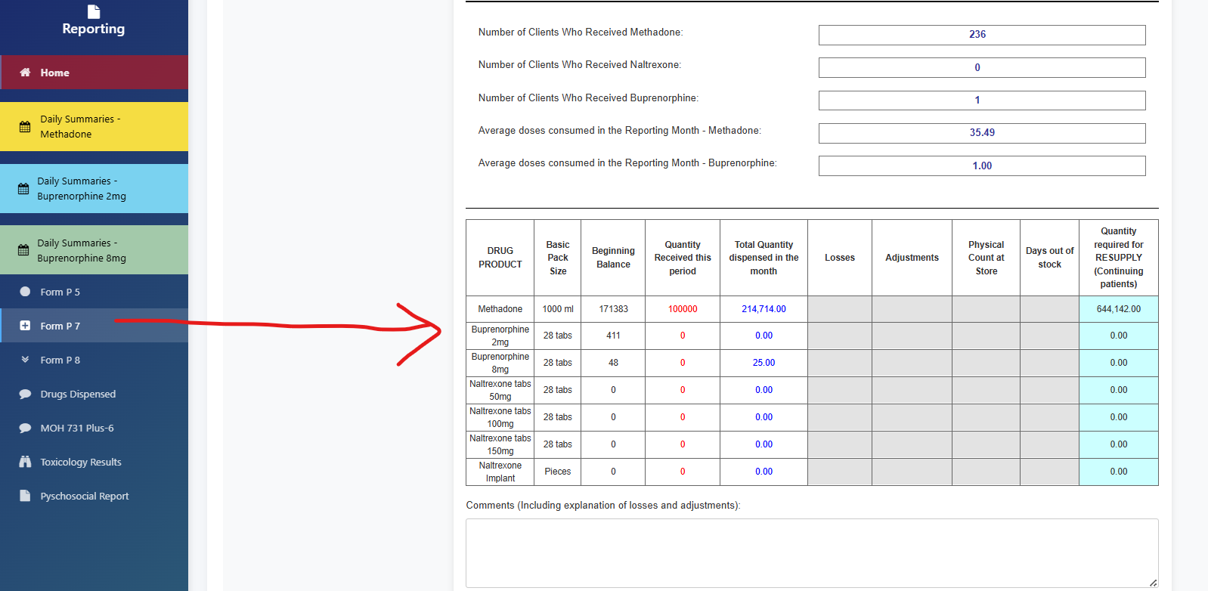

1. To select the specific month report, select the start date and end date from the display form and click ‘Update dates’

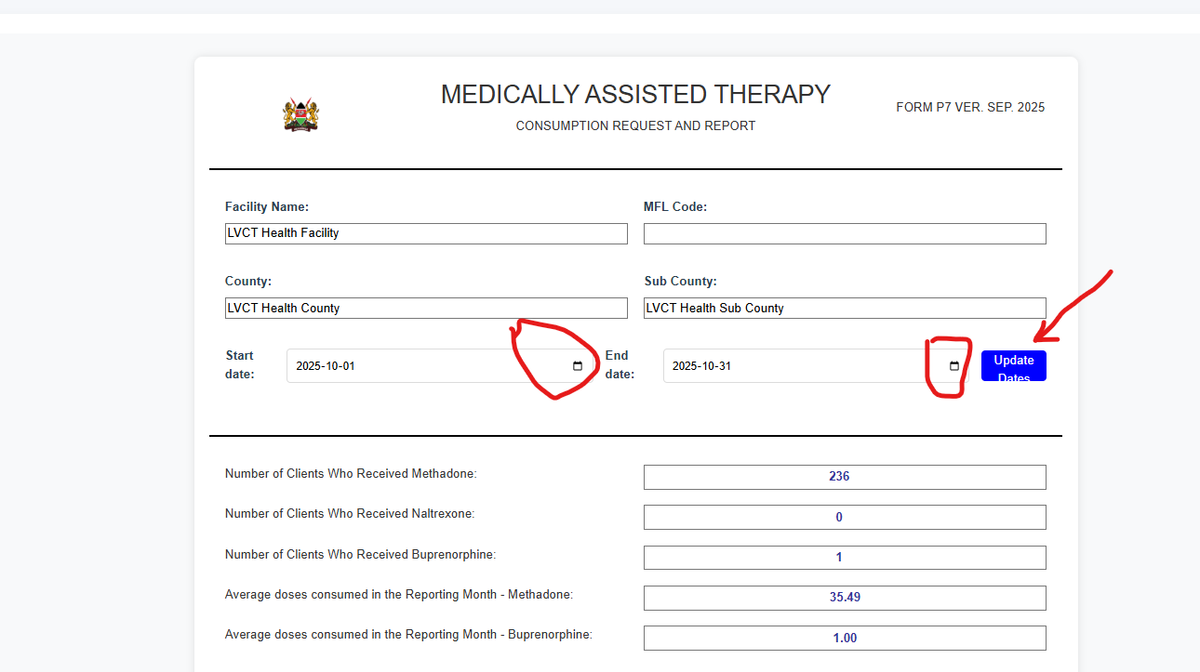

1. Fill in the details in the form below (mobile phone and date of submission) and click print. The form will be saved and can be emailed to MAT in charge or Sub County Pharmacist

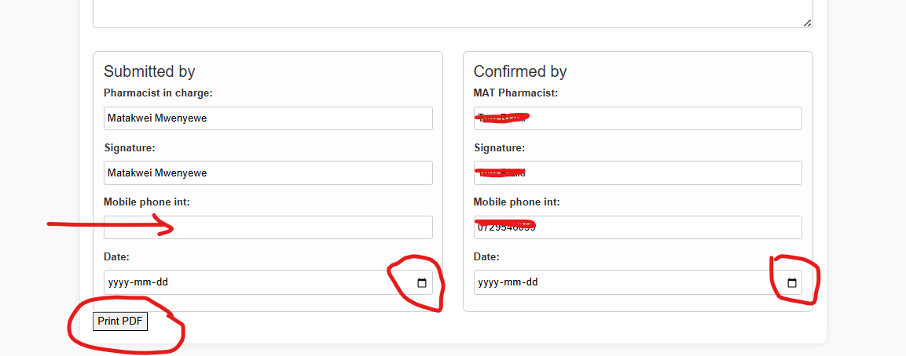



## P8 Form generation

1. For from P8 when you select the Form P8 form it displays by default the report of the previous month. Example when the current month is November, the form will display report for October

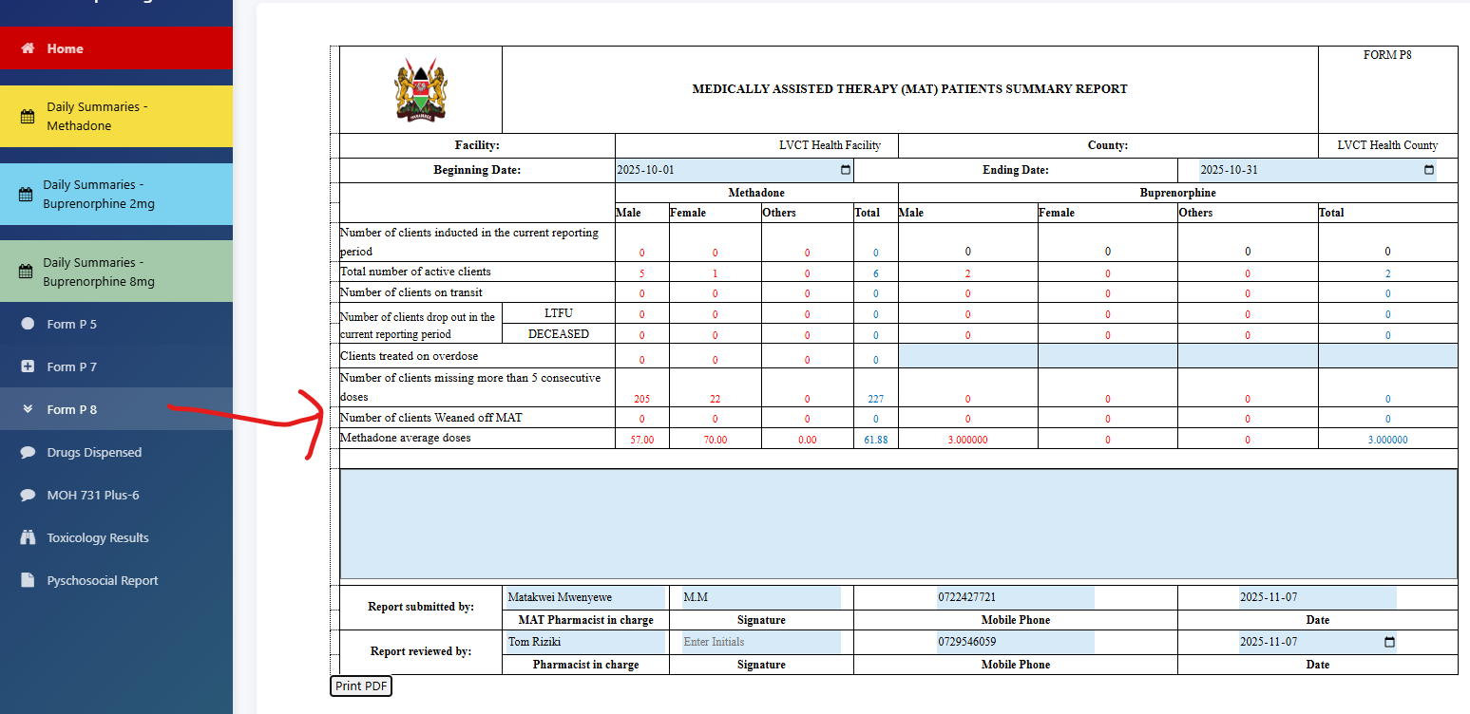

## Form MOH 731-6 Plus

1. Click on the MOH 731-6 plus
2. Select the start date and end date from the calendar dropdown
3. To select the specific month report, select the start date and end date from the display form and click ‘Update dates’

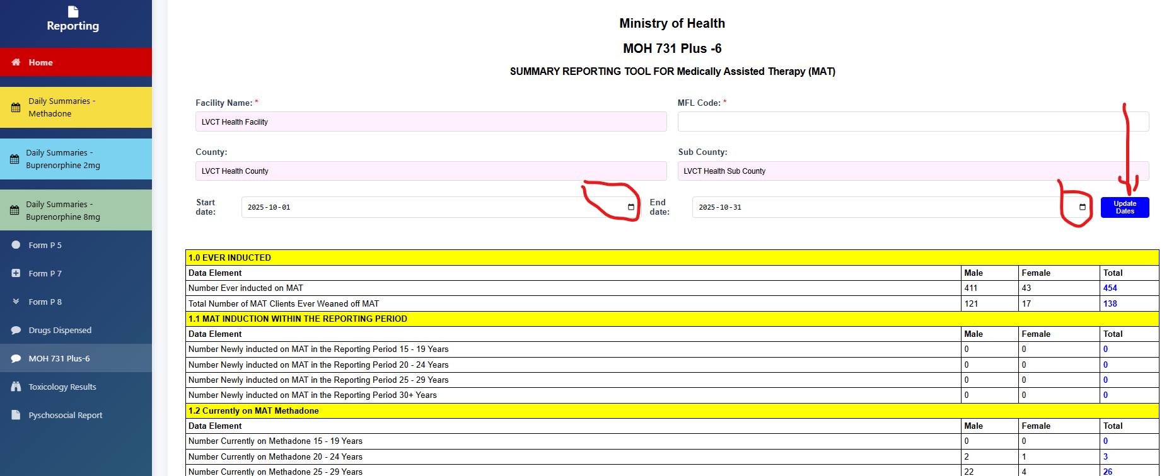

1. For from MoH 731-6 Plus, when you select the MoH 731-6 Plus form it displays by default the report of the previous month. Example when the current month is November, the form will display report for October
2. Print as PDF and email to the in charge or save in a folder

## Toxicology Results

1. For from toxicology results, when you select the toxicology tab it displays a list of clients who have had toxicology tests done

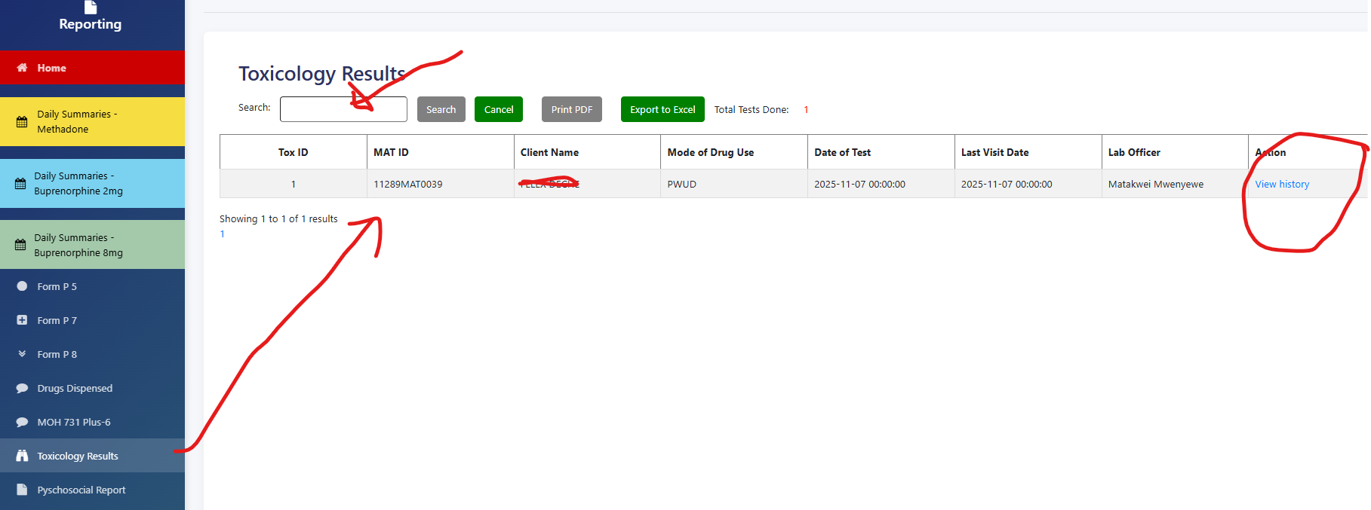

1. Search using client name or MAT Id and click view to see the details of clients toxicology history

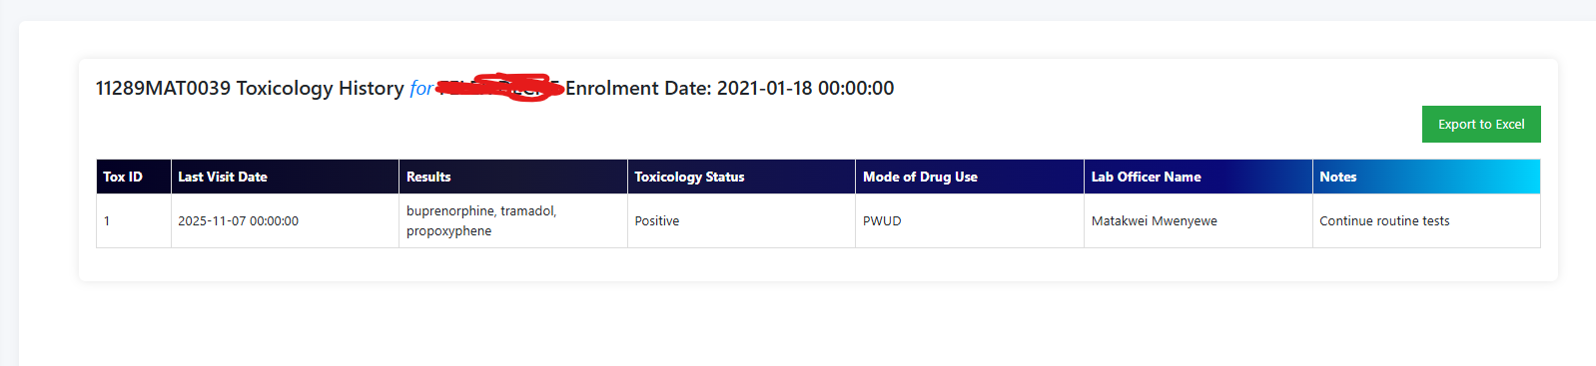

## Psychosocial Form

1. For from Psychosocial form, when you select the Psychosocial report it displays by default the report of the previous month. Example when the current month is November, the form will display report for October
2. To select the specific month report, select the start date and end date from the display form and click ‘Update dates’

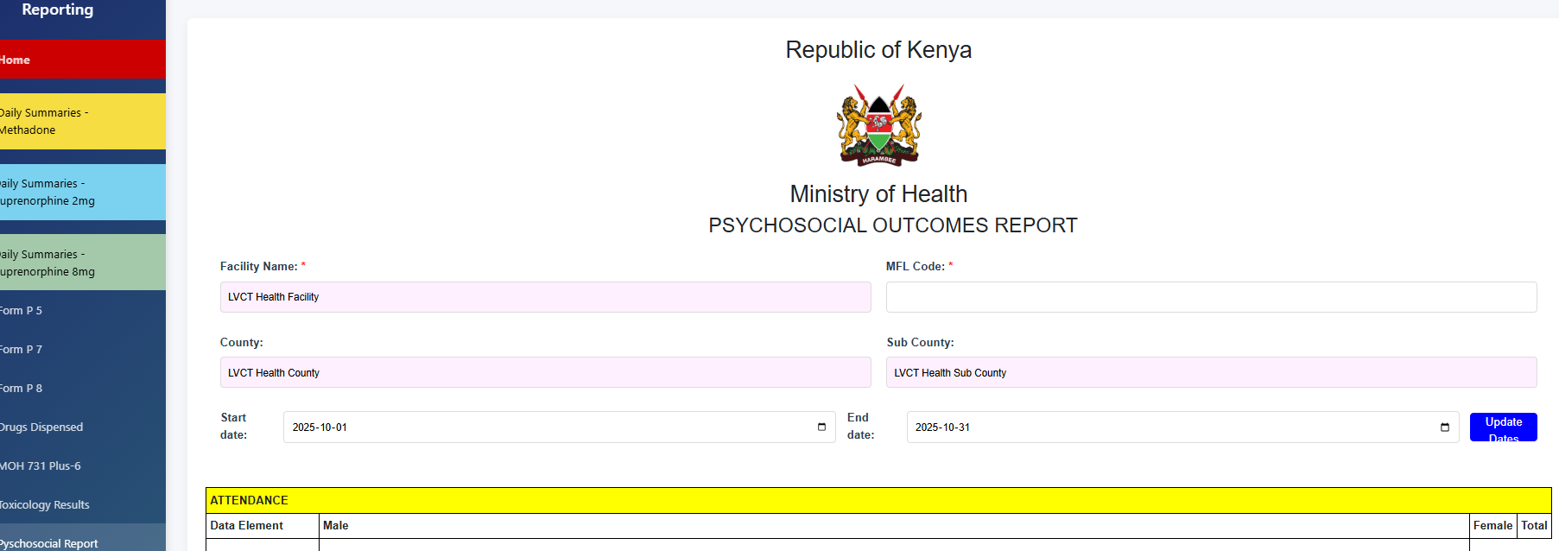

1. Click home tab to go back to the main dashboard

# BIOMETRICS

## Capture photo

1. Click on the biometrics module to open the search page and enter the name or MAT ID

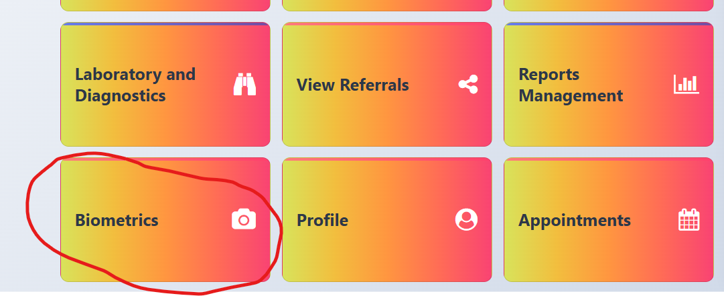

1. If the photo status shows ‘no photo’ click on capture photo

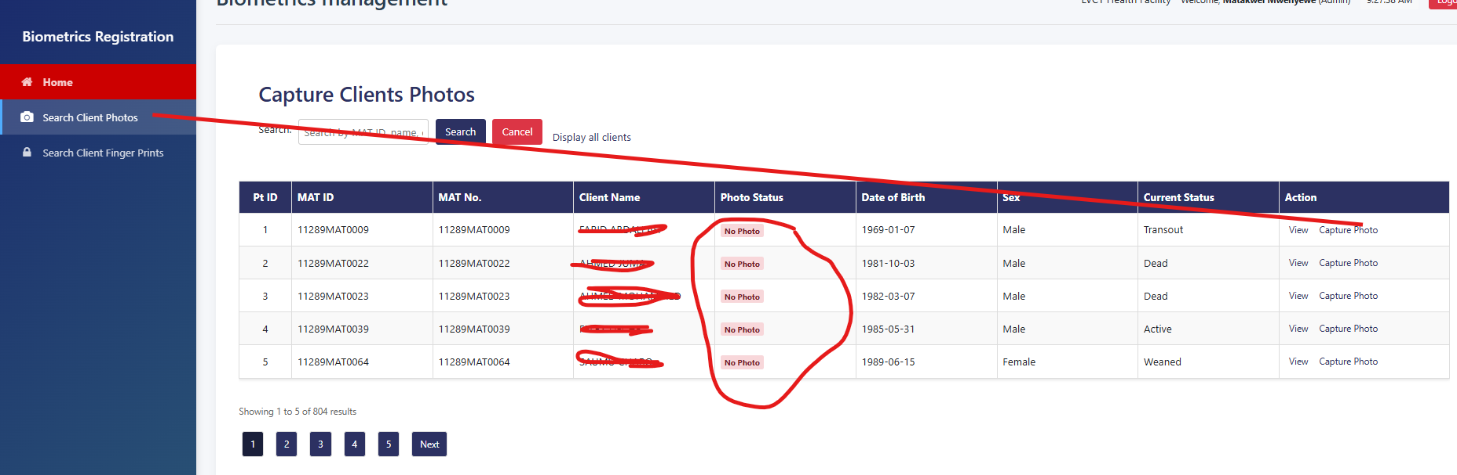

1. Capture photo and save

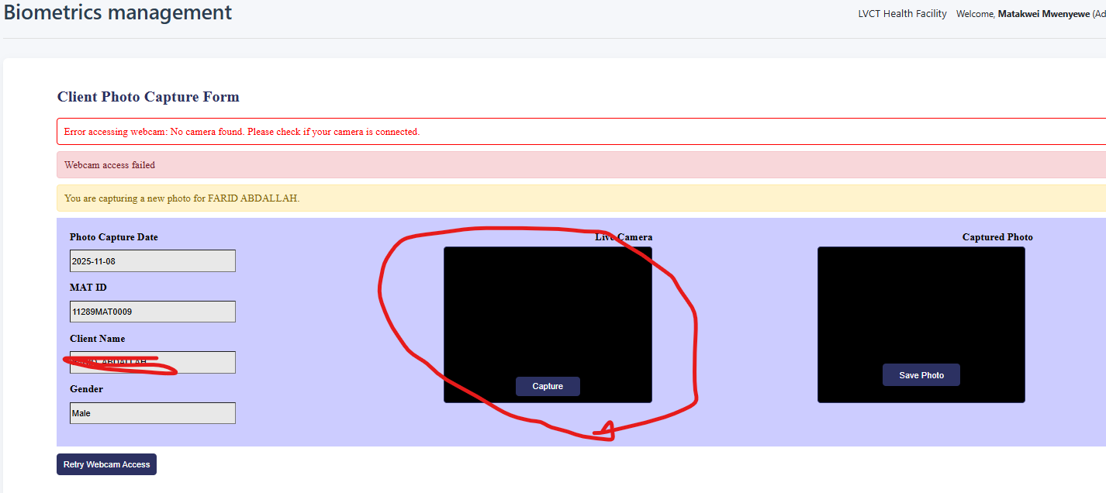

## Fingerprint capture

1. For finger print, search for the name or MAT ID and if ‘Not registered’ click register fingerprint

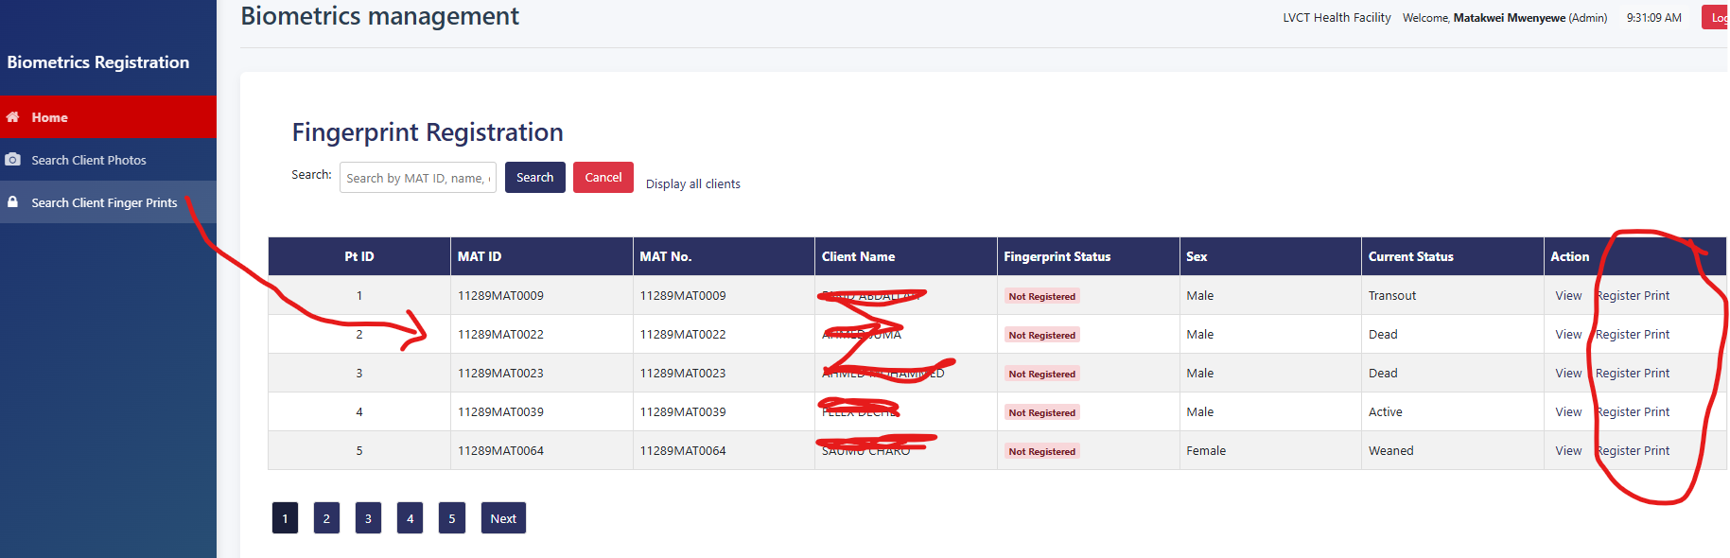

1. The client places the finger on the scanner then click “Start Capture” when the fingerprint displays, click save fingerprint

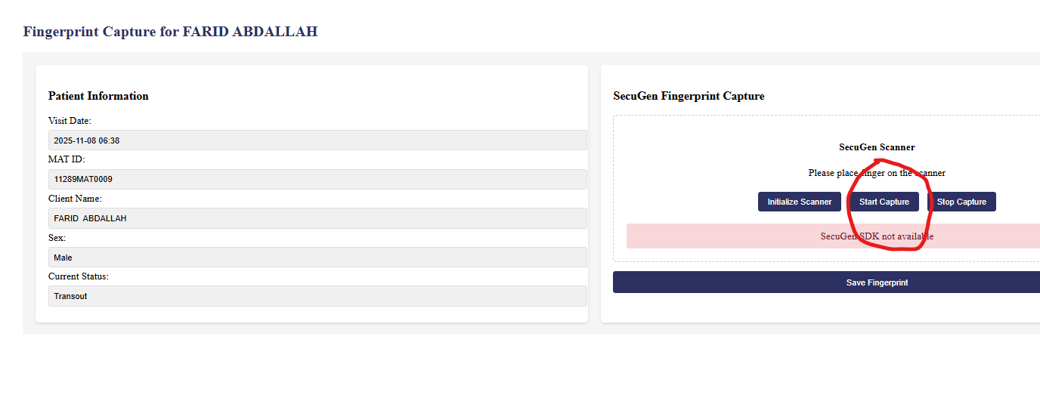

# PROFILE

## View profile

1. Click on ‘Profile module’ on the dashboard

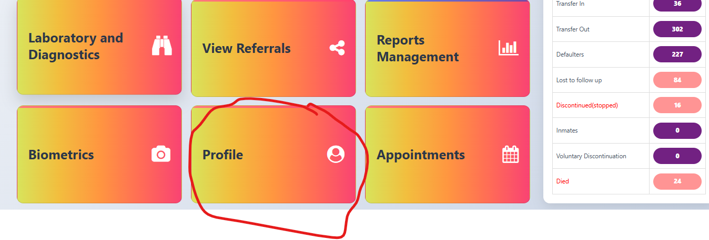

1. Click ‘View profile’

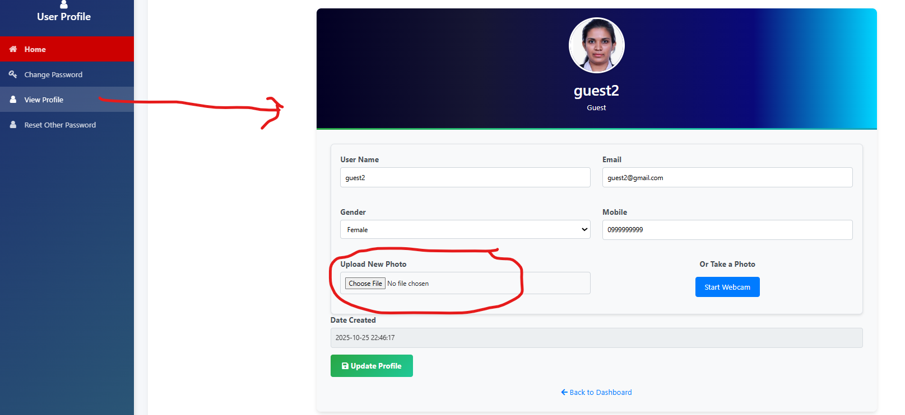

1. If your profile has no photo and you have it in a folder, click ‘Upload new photo’ and once done click “Update profile’
2. Only Admin can update the users’ role

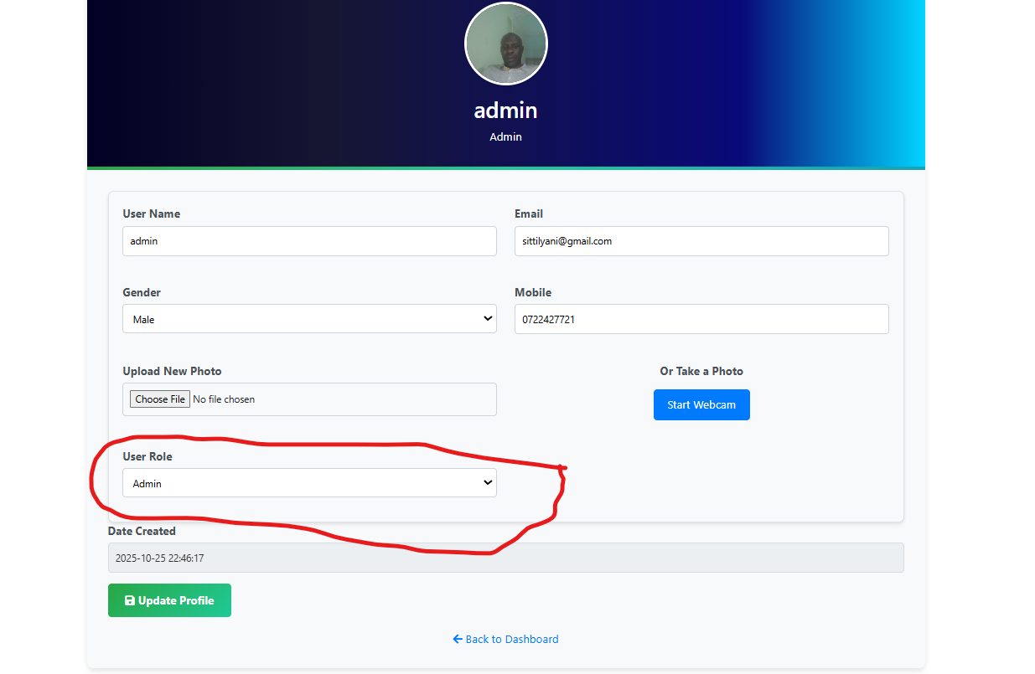

## Change own password

1. Click on ‘Change password’

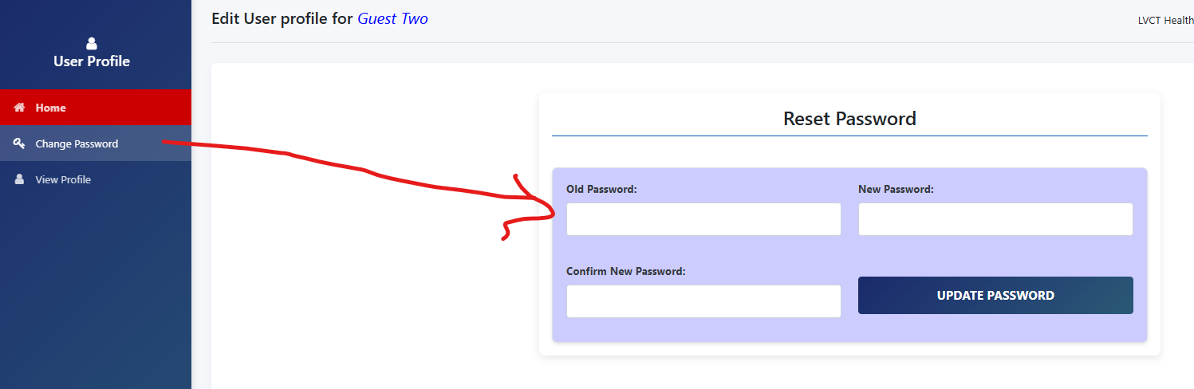

1. Enter the old password
2. Enter the new password and enter the same password in the confirm new password input and click “Update password’ wait for success message at the top of the page and click OK

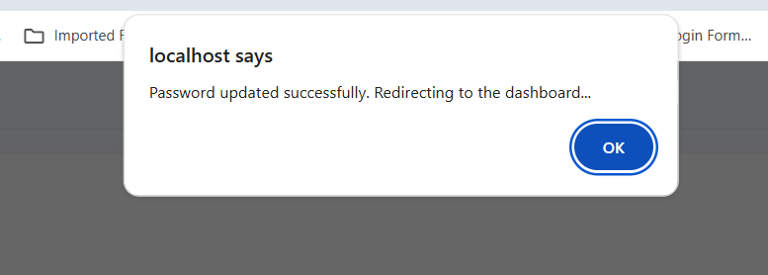

1. Click home button to continue with other operations

# APPOINTMENTS